 | IST-2002-002114 – enactive network of excellence  JPA3 IA3 EES CREATIVITY
Reference | EI_EES_Creativity_Believability_Pebblebox
Title | EES5.4 Believability and the Pebble box
Object | EES5 Deliverable Chapter 4
Authors | Elena Pasquinelli
Participants

Dissemination | Enactive partners
Nb of Pages | 24
Date of the version 12.10.2007 | 2007, December 5th
Confidentiality | ENACTIVE Internal Restricted Use

Partners Contributions | Planned | Done
INPG – 1,5 PM | - Leading of the task.  - Implement the EES on the High fidelity ERGOS simulator  - Organization of the experimental activities: participation of enactive partners  and of artists.  - Participation to the experimental activities  - Finalizing the presentation of the scenario | - Leading the task  - Implement the EES on the High fidelity ERGOS simulator  - Organization of the Workshop EES Creativity in Grenoble February 2007 on which experiments are carried out.  - Participation to the experimental activities  - Finalizing the presentation of the scenario: implementation of a autonomous interactive scenario for large audience experiment without the presence of an experimenter.  - Organization, of the presentation of the EES at Enactive 07  - Participation at the experiments during Enactive 07 EES
INST Nicod  0.2 PM | Contributing to Forum DISCUSSION on-what exactly to do with the platform to  make an attractive scenario -what makes the scenario characteristically enactive  -inventing and deciding on precise experimental protocols -discussing their  significance | - Launching and moderating discussions through WEB  - Production of an orientation document on Believability  - Participation at the experiments during Enactive 07 EES
QUB  2.0 PM | To develop the prototype instruments for task1 and to carry out evaluations of  EES5 prototypes. | - Participation top the development of Pebble Box EES  - Participation to the Workshop EES Creativity in Grenoble February 2007 on which experiments are carried out.  - Participation at the experiments during Enactive 07
ULUND  0.0 PM |  | - Participation to the Workshop EES Creativity in Grenoble February 2007 on which experiments are carried out.  - Participation at the experiments during Enactive 07

Table of Contents

Chapter 1: Ergotic Sounds: A new way to improve Playability, Believability and Presence of Virtual Musical Instruments

Abstract

In this Emblematic Enactive Scenario, we explored how “ergotic gestural-sound situations”, i.e. the situations in which the instrumental gesture and the produced sound are intimately energetically linked, is a natural way to guaranty the playability, the believability and the presence of the musical virtual instrument. The chosen experimental situation is the evaluation of a difficult musical pattern in a bowed string performance that consists in maintaining the continuity of the sound when changing the bow direction. This pattern is objectively observable on the signals and subjectively identifiable by performers and audiences.

Keywords: Haptic-audio interaction, force feedback interaction, ergotic sound, physically-based modeling, instrumental interaction, bowed string.

1.1 rgotic sounds
In the musical performance situation, it is useful to distinguish two types of relationships between the gestures of the player and the sound produced:
• Non-Instrumental Musical Practices, such as the musical conductor situation, or when controlling synthetic musical parameters by mapping techniques (Figure 1) [Nichols 2002][Hunt et al. 2003].
• The Instrumental Musical Experience, as when an instrumentalist is playing a physical instrument (Figure 2).

In non-instrumental practices, there is no energetic exchange between the human gestures and
body activity and the sound so-controlled.

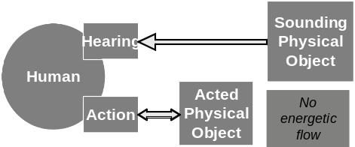 | 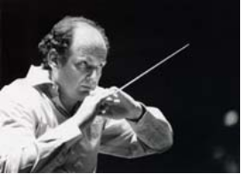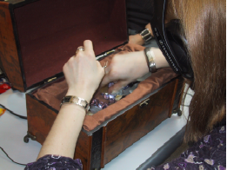

Figure 1. Non -Instrumental Musical Practices: A Non-Ergotic relationship to the sound

Conversely, in the Instrumental Musical Experience, the performer and the played object are physically dynamically coupled during the playing. [Essl and O’Modhrain 2006] and earlier several authors quoted in their paper, insisted on the importance of tangibility in musical instrument design.

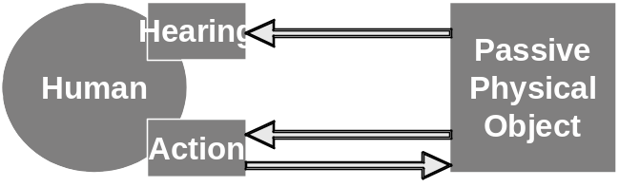 | 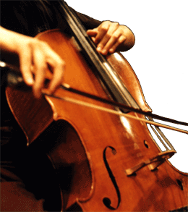 | 

Figure 2. Instrumental Musical Practices: An Ergotic relation to the sound

The sound produced engraves the physical energy exchanged between the performer and the physical musical instrument. Such “Ergotic sounds” refer to an « Ergotic Relationship to the sound » according to the typology of relationships between human and environment proposed by [Cadoz 88][Cadoz, Wanderley 2000].

As also emphasised by [O’Modhrain et al. 2006], we assume here that the instrumental musical experience in its elementary principles, is an emblematic case of Enaction. It exhibits the main features characterizing the enactive theory of cognition:
• The world without representation [Clark et al. 1994]: the representation of the instrumental situation can only be the situation itself.
• Cognitive shapes do not pre-exist: they are emerging from the interaction with the environment: The meaning (e.g. musicality) emerges from the instrumental situation itself.
• Enactive knowledge acquired during the experiment is a robust knowledge: the learning of the performance (the task) and of the musicality (cognitive category) emerging during the performance itself leads to a robust performance knowledge.

The role of the energy exchange between the instrumentalist and her instrument - or of the physical effort of the instrumentalist -is well recognized when playing mechanical musical instruments. In addition, there is common acceptance that something is missing in the interaction between a musician and a conventional digital musical instrument, particularly prior to the arrival of force feedback interaction.

We may assume that the ergotic relationship to the sound is an important feature for playability, the believability and the presence of the musical instrument, a factor that has to be re-introduced in digital musical instruments.

However, we are confronted by one principle obstacle when trying to prove this common assumption, namely the difficulty of adding sensors to real mechanical instruments to observe the relationship between gestural input and force feedback without altering the nature of the interaction.

We may assume that the virtual musical instrument may be a very new experimental set-up able to contribute to the knowledge of what happens during an “ergotic instrumental situation”.

In the following, we describe (1) the experiment we designed to capture the main feature of ergotic musical situations, including a description of the technical real time platform implemented to serve this objective and the physically-based model of a virtual bowed string (cello or violin-like model), and:
(2) the first set of results obtained from a pilot experiment performed with 10 subjects using this experimental platform.

1.2. The Virtual Cello-like experiment: Experimental set-up

1.2.1. he Physical model of the bowed string
In order to test the foregoing assumption, it is necessary to develop a platform that represents an implementation of the ergotic relationship between gesture and sound. Such an implementation should be different from an implementation based on the conventional digital musical instrument model (i.e. a control mapping concept), with or without force feedback.)
In the mapping concept implementation (figure 3), there is no consistant energy source modelled between the parameter control part (composed of a gesture acquisition process using sensors and a mapping process of the gestural inputs to the parameters of the computer sound synthesis process) and the production sound part. The data flow between the two parts is unidirectional from the first (gesture side on the left of figure 3) to the second (sound side on the right of figure 3).

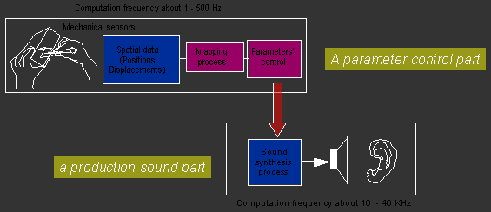
Figure 3. Mapping process

When extended with force feedback gestural interaction, as in [O’Modhrain et al. 2000][Nichols 2002][Rimell et al. 2002][Sinclair et al. 2007], the gesture side is improved by a local physical model to produce the force sent to the hand, but there is still no bilateral interaction from the vibrating string to the manipulation part. Even though we may assume that the vibration of the string is not felt by hand, it is known in acoustics that the physical interaction from the string to the bow at the acoustical frequency of the string plays an important role in bowing.

The implementation of the virtual bowed string model, that respects the bilateral physical interaction throughout the instrumental chain, between the hand and the bow and between the bow and the vibrating structure, has been implemented in [Florens, 2002]. It is described in Figure 4, that shows:
• the two bilateral interactions between the bow and the vibrating string on the right of the figure (on the right of the vertical line): interaction for the transversal motion (buffer interaction representing the collision and the pressure between the bow and the string) and interaction for the lateral motion (friction interaction). These two interactions are coupled to satisfy a main characteristic of the bowing: the friction law depends on the pressure as shown in Figure 5.
• The bilateral interaction between the bow and the hand through a 2D force feedback device returning the pressure force and the friction force from the bow.

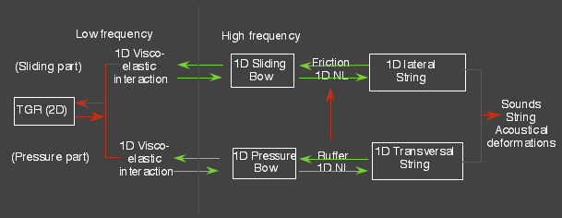
Figure 4.Physical model of the bowed string

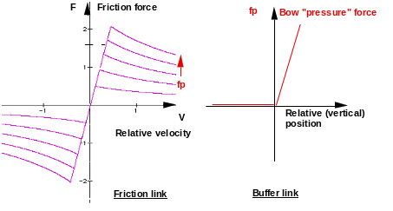
Figure 5. Dependency between friction and pressure interaction

This implementation guaranties the ergotic nature of the situation as it exists in real mechanical instrumental playing. There is no break in the modelling of the energetic consistency between the hand and the ear.

1.2.2. The high quality ERGOS Experimental Platform
The technical platform has to guaranty two constraints:
• the real time simulation of the previous model
• with a sufficient quality to be sure that the main features that exist in the real situation can be captured , or at least not unduly biased by the system.
Implementations that do not guaranty the physical response comparible with the real system, e.g. those based on more conventional digital musical instrument architecture [Sinclair et al. 2007] cannot be exploited in such experimental evaluations.
Some years ago, [Florens 2002][Luciani et al. 2005] developed a fundamentally reactive implementation based on a synchronous computer architecture and the high fidelity haptic ERGOS technology [Florens et al. 2004]. In this design, the previous bowed-string model has been implemented with two interdependent frequency loops: 3 KHz for the hand-bow loop and 44 KHz for the bow-string loop. The acoustic results as well as the relationship to the instrumental action were very impressive and were tested several times by a variety of users. However, we are not yet sure whether the hand’s sensitivity to the vibration of the string (not rendered here) does not play an important role, e.g. in the playability or at the level of supporting the cognitive or perceptual realism of the virtually constructed instrument, even with force feedback.
instrument.

In other words, is the gestural sensitivity of the vibrating string, although filtered by the bow and by the mechanical human body, important, and for what? While such a question has never been asked in this exact form, Askenfeld [1992] and Chafe [1993] have provided evidence that such haptic cues are certainly available to a player. By attaching accelerometers to the bridge of a ’cello and to the finger-nails of the player’s left hand, Chafe was able to record the vibrations transmitted from the string to the hand and the body of the instrument. Though much of the energy in the steady state portion of this note is too high to be useful to the haptic system whose peak of sensativity for vibration lies at around 250HzVerillo [1992], the burst of energy at the note’s onset contains components that can be felt.

In the current study we assumed that, if we wanted to test the role of the ergotic component of the interaction, we would need to allow for experimentation with respect to such subtle features: realising the feeling of the vibrating string within the hand. Consequently all the parts of the previous physical model will be implemented at the frame rate of the sound, i.e. at 44 KHz (Figure 6).

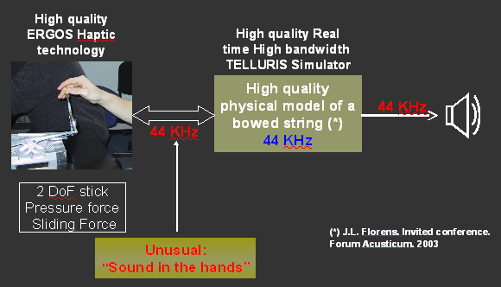  Figure 6. Functional diagram of the high quality experimental ERGOS platform | 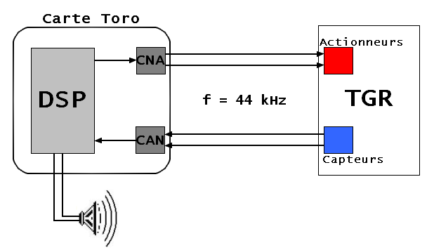  Figure 7. Technical description of the platform

To guaranty these requirements, the entire model has been implemented on a DSP board (Figure 7) directly connected to the force feedback ERGOS device (TGR on figure 7) by high reactive DAC/ADC and the sound is directly picked up from the DSP board.

The reaction time between input action and force feedback as well as between input action and sound are both of 1/44000 ms, and totally synchronous at that rate.

1.2.3. The experimental protocol
The experimental protocol is composed of two phases:
• A preliminary experiment, with general subjective questions about “the feeling of friction”
• A second experiment with much more precise performance goals.
• Preliminary experiment: qualitative appraisal of friction

Due to the quality of the model, we observed during a preliminary pilot experiment in which persons manipulate the force feedback device and hear the resulting sound, that all the persons conclude systematically that the manipulated object is without doubt a bowed string, and all comment on the feeling of the friction in the hand. This signifies that, since the bowed string sound is heard, the feeling of the gestural friction as a separate component is masked. In the introduction phase, subjects are confronted with four types of gestural feedback, first without sounds and second with sounds, and in both cases (with and without sounds) with two types of strings. Subjects are asked to describe their feeling by trying to identify and describe the virtual object they expect they are manipulating.
After a preliminary case, of no feedback (no friction and no pressure), the four types of gestural feedback, with a nominal pressure (corresponding to the real elasticity of the string), are:
(0): no friction
(1): subtle friction, i.e. lighter than in the real case
(2) normal friction, i.e. closer to the real case
(3) exaggerated friction, very higher than in the real case (the bow is sticking hardy to the string).
The two cases of strings are : high frequency (high pitch) and low frequency (low pitch). Without sounds, the pitches are not heard.

• Core experimental phase: goal to be reached
We selected for this study a difficult goal, which is deimed to be impossible to accomplish without being conscious of the ‘feel’ of the bow on the string. The task consists in “(1) Maintaining the continuity of the sound (2) when changing the bow direction”, where (1) is a musical constraint and (2) is a gestural and mechanical constraint. Both being contradictory, (1) they are fundamental skills and (2) a high level of expertise (and hence much practise) is necessary to achieve satisfactory performance in the case of the real mechanical instrument.
This feature is objectively observable in the signals as shown in a snapshot in Figure 8. When changing the direction of the bow by maintaining the continuity of the sound, the bowing movement is inverted (3), but the phase of the string vibration is not changed. We have to notice this phenomenon well known in musical perception, that the perceived sound may change (for example in its timbre or its amplitude) but when the phase is not changing, perceivers interpret that there is “continuity of the sound”.
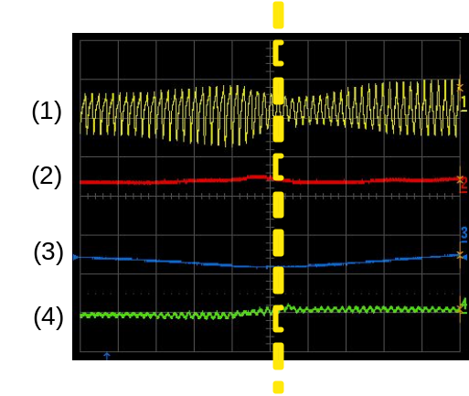
Figure 8. Signals corresponding the bow direction changing. (1) Acoustical vibration of the string, (2) pressure force of the bow on the string, (3) Displacement of the bow, (4) Sliding force of the bow.

It is also subjectively well - identifiable by the performer and by the audience. Performer and audience are invited to point out when the goal is reached and the moment when the subjective success occurs is noted in order to compare with the objective signals.

All the performances and performers comments were recorded on video camera and the audience comments to audio.

1.3. Experimental Results
Both experiments, “preliminary” and “goal-directed”, have been undertaken by 10 participants (25 to 55 years old), 4 females and 6 males, 6 non professional musicians (3 totally novices and 3 with a small amount of instrumental experience) and 4 musicians.

1.3.1. Preliminary experiment “feel of friction” with and without sounds

In the experimental paradigm used, the manipulation of the virtual bowed string is totally free in terms of the type of gestures to be performed and in the duration of playing. The answers to the questions are also totally free. The questions asked for each experimental conditions (see paragraph 2.3) were as follows:
a. Without sound feedback:
• How do you qualify what you are feeling (several answers are possible)?
• According to you, what is the object you are manipulating (several answers, as well as doubts, possible)?

b. With sound feedback:
Before asking the two previous questions, a first question is asked:
• Is the haptic feeling the same as in the previous experiment? Describe freely the similarities and the differences you perceive.

The main observations are:
1. For most of the participants, haptic feeling is not the same with sound as without sound.
Without sound, friction seems rougher than with sound. Roughness is dominant.
2. For most of the participants, without sound, the haptic feeling is never close to that of a real instrument but it is closer to the real instrument in case (1) and (2). Notice that the answers are the same even for people who never played cello or violin. This means that :
• in real playing conditions, they don’t give as much attention to the haptic sensation. They don’t know (or imagine what the haptic sensation of playing the real instrument is).
• they infer from the sound what the feel of friction on the real instrument could be. It appears that, without sound, they are unable to imagine what the feel of a bowed string might be, indicating a tight perceptual coupling from audio to tactile perception, but not the other way round.
3. Without sound, no participants identified a string. However, people evoked freely objects such as zipper, rattle, wheel friction on road, etc. On the contrary, with sounds in all the same situation (null slight, normal and exaggerated friction), all the participants concluded that what they were feeling was a bowed string. This means that sound is predominant in this particular object identification and that there is a haptic-sound co-reinforcement leading to a correct haptic feeling, correct in the sense that it corresponds to what is actually implemented.

The main result is that all the participants are surprised when they discover that the objects are the same in both cases (without and with sounds). The friction sensation in a mechanical bowed string is not really known, even for musicians. Even the persons that never manipulated bowed strings before inferred the feel of friction on real instrument from the sound. There is no focus on the sensation itself. The focus is instead on the identification of the manipulated object. Thus for the bowed string sound is predominant when identifying the correct virtual object.

1.3.2. Core experiment: “reaching a goal”
As explained in the paragraph 2.3, the core experiment consists in reaching the goal of “maintaining the continuity of the sound when changing the bow direction”. Success is observed on objective signals and by asking the performer and the audience. The subjects who performed the task are the same as in the preliminary experiment. They play freely for the duration they want. The audience is composed of the other participants and 10 other ‘observers’ from the laboratory, most of whom were naive as to the purpose of the study.

1.3.2.1. Occurrences of the success of the task
The main observations are the following:
• With Slight or Normal Friction:
Most of the people complete the goal task several times, even if they estimate that they are poor or non expert players, and do this within a time period of 15 minutes at maximum.
The occurrence of success is greater than in the case of a real bowed string, though the movement is constrained to one plane in the horizontal axis, unlike the case with a real string.
• With Exaggerated friction:
Here, very fewparticipantse reachd the goal. For all participants, the playing is difficult and non satisfying.
• With Null friction:
Again, very few participants reached the goal of a satisfying performance, though significantly all the scores are better than with exaggerated friction. Most people estimated that they could improve with practise.

In summary, these important preliminary results indicate that adequate well-tuned ergotic relationship between gesture and sound is important to achieve success in this goal task.

1.3.2.2. Cognitive styles
A further very preliminary observation was that the manner of exploration employed by each participant appeared to depend on a priori cognitive styles:
During the first minutes of playing, some people are caught by non dynamic features such as :
• spatial features : they started by focusing on geometrical properties such as curvatures: when manipulating the stick, they feel first a kind of concave surface on which the stick is sliding with friction. This concavity is due to the morphology of the force feedback device. This feature is not remarked upon by most of the other subjects
• Musical features: composers started by focusing on seeking a predetermined musical feature.
Progressively, and quite quickly (i.e. in less than 15 minutes), they were attracted by the dynamic of the playing and started to explore with new non predetermined gestures guided by the dynamics (changing the force, accelerations,, velocities, gesture trajectories; etc.)

1.3.2.3. Modes of Playing and dynamic adaptation
A very obvious observation made by all the persons of the audience and confirmed when examining the video movies was the changing nature of gestures: there is a continuous adaptation of gestures to find the best way of manipulating the device to reach the goal. Some examples are shown in photographs (see Figure 9):
• Exploration of various modes of grasping and postures: With fingers, hand palm, wholearm, strong full hand grasping, etc.
• A wide Exploration of dynamic strategies:
- Transforming the bow direction changing in soft round turning
- Road turns, Möbius-style movement, elliptic trajectories,…
- Modulating the cinematic of the gestures
- Acceleration - deceleration at the point of changing
- Relaxing the pressure before or after the turn point, Etc.

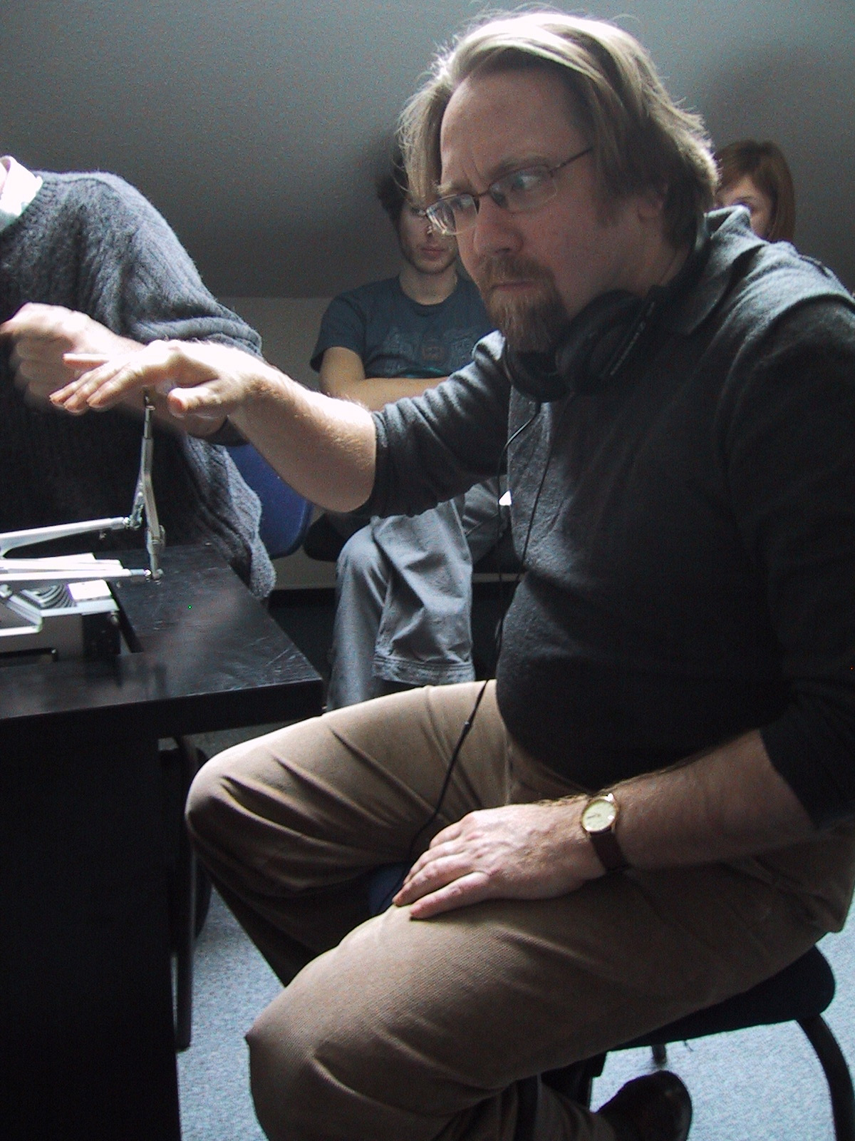 | 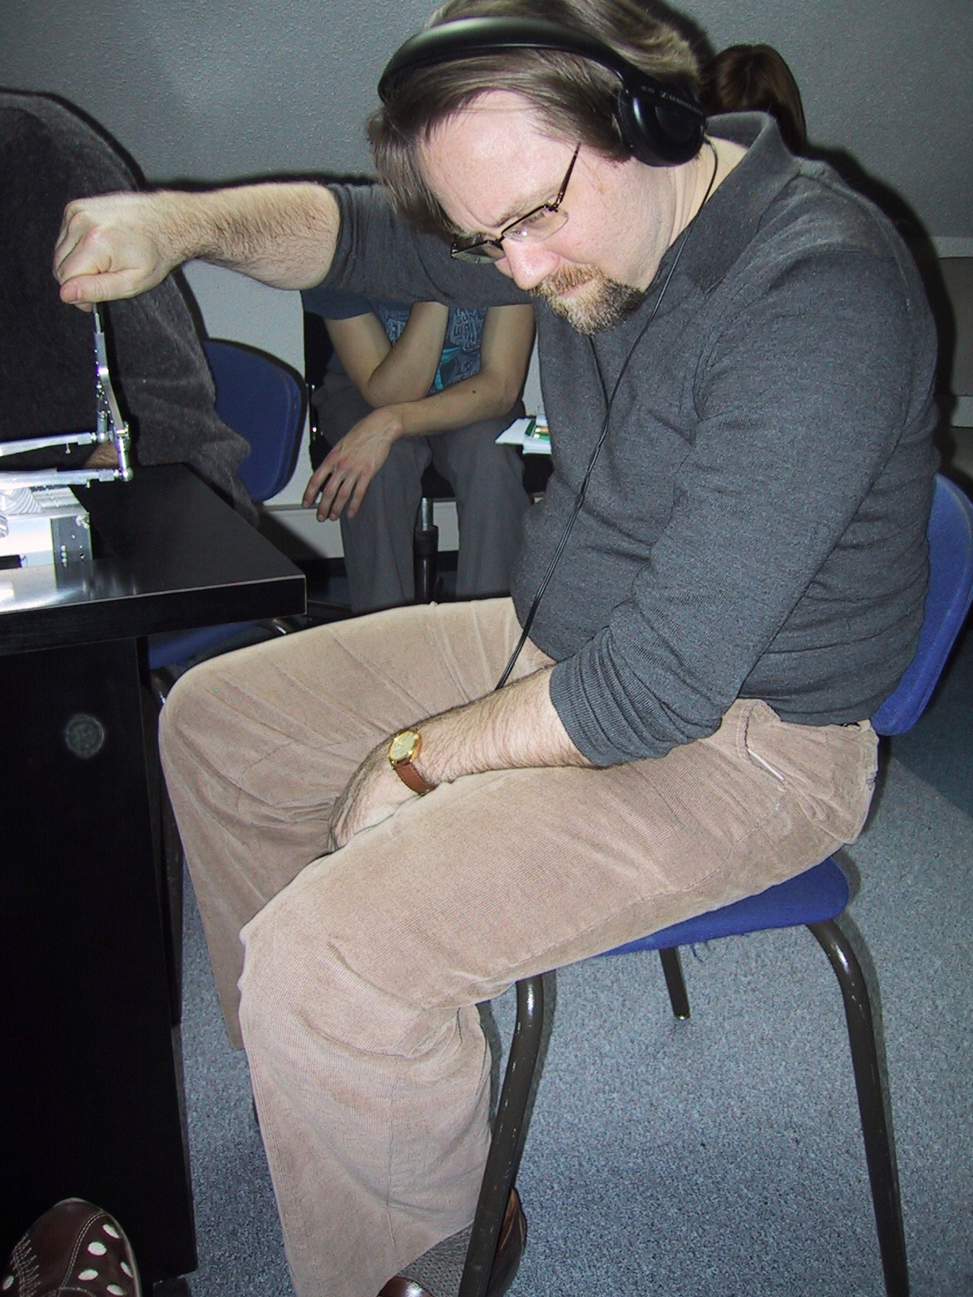 | 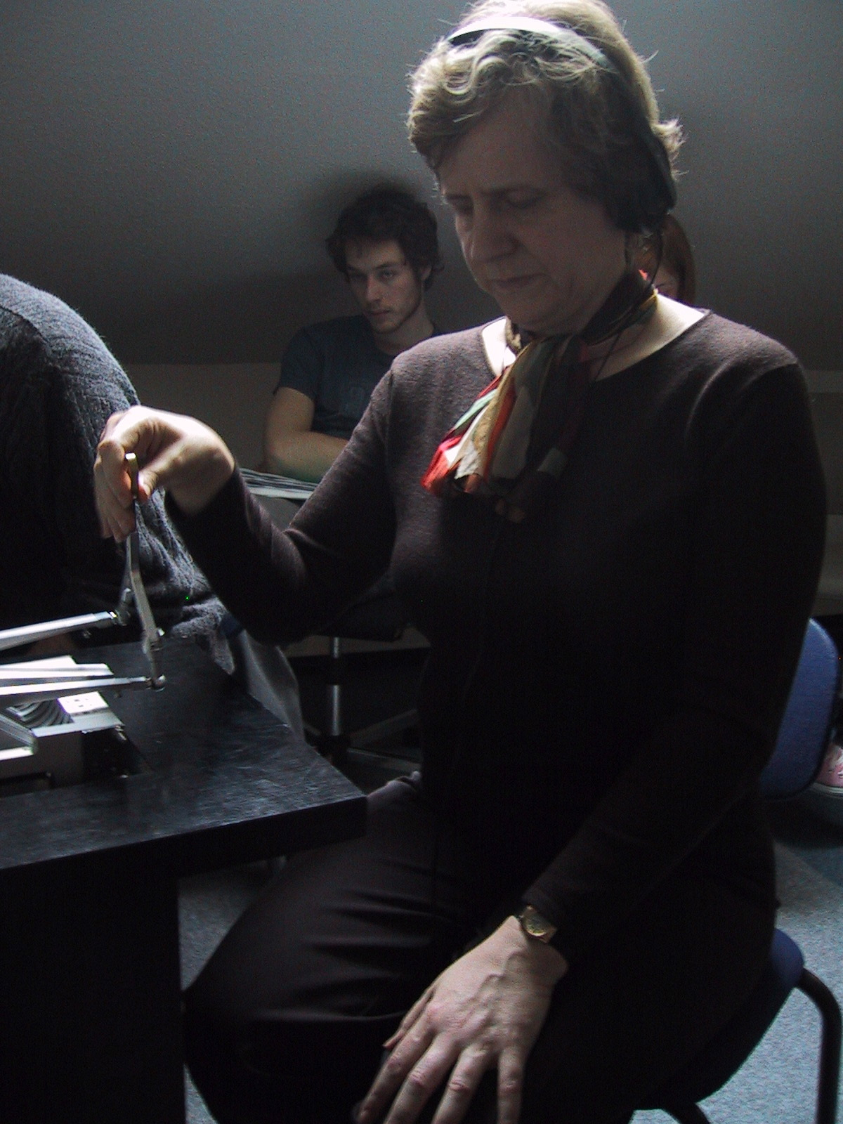

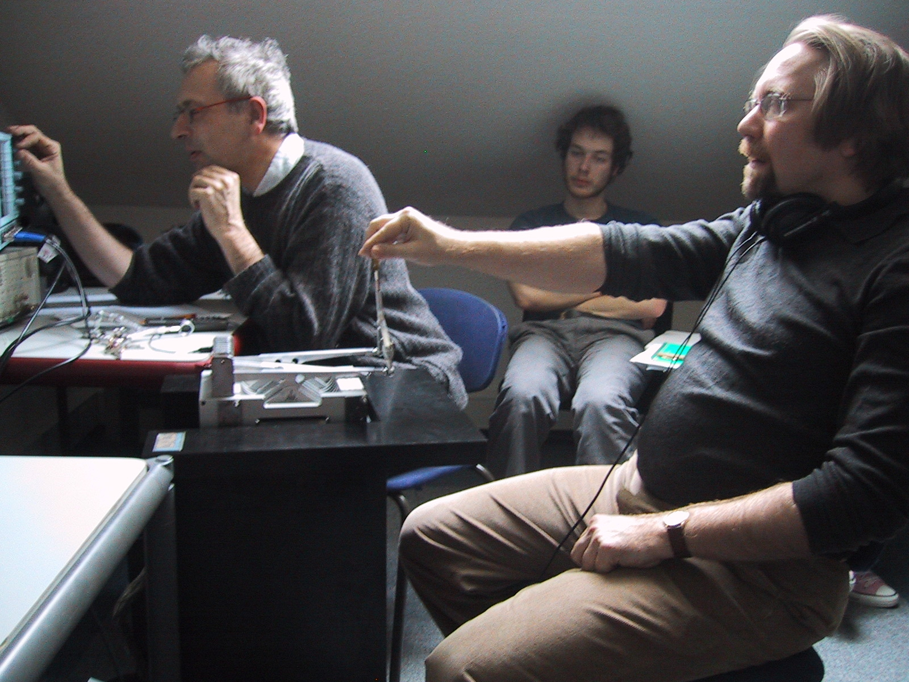 |  | 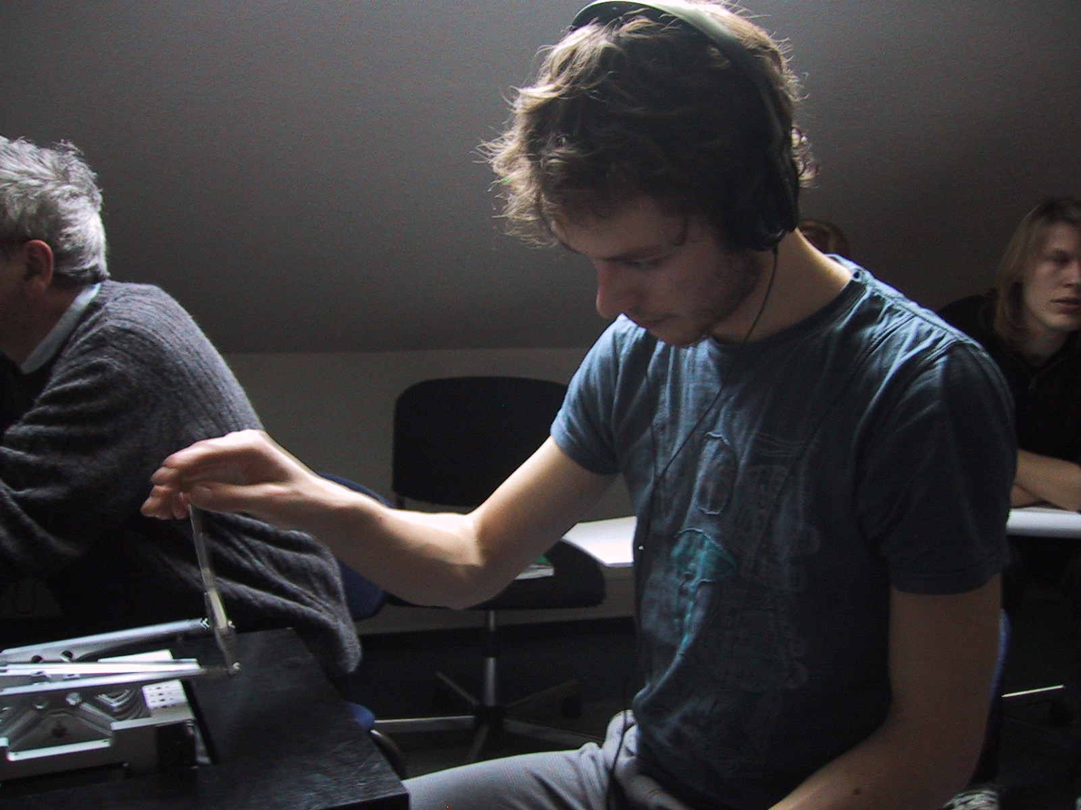 | 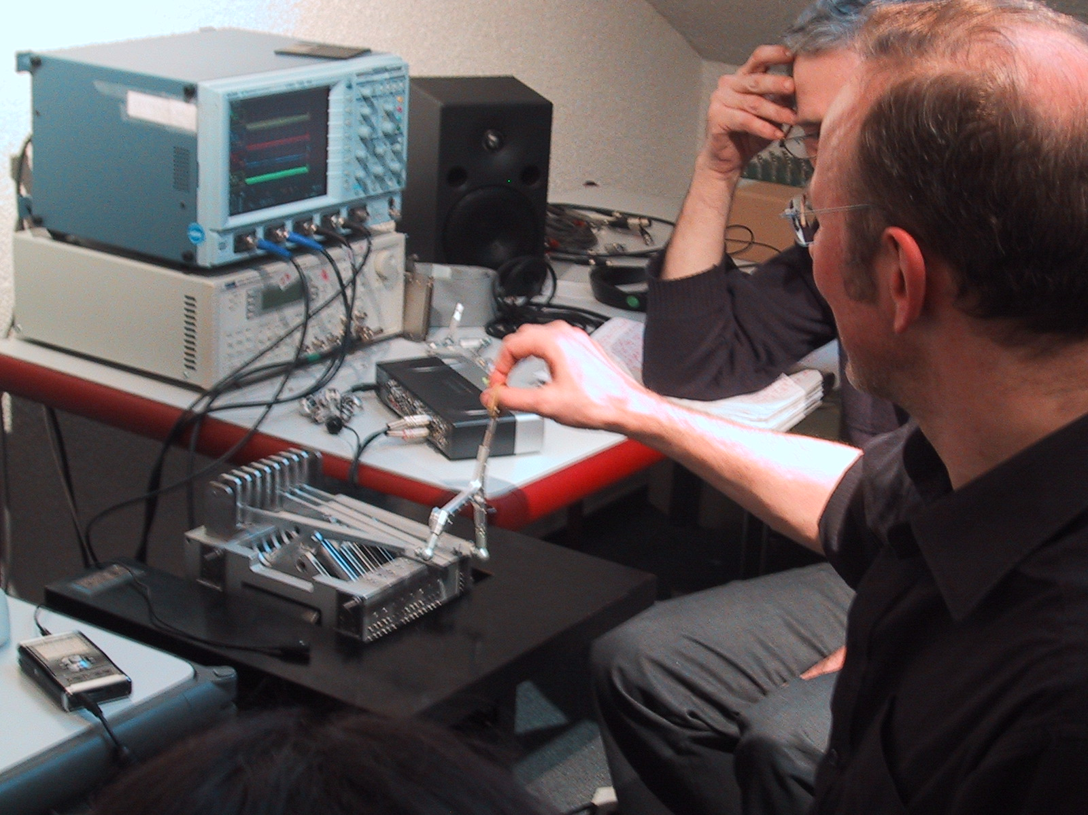

Figure 9. Exploration of different way of playing to reach the goal.

1.3.2.4. Continuous Dynamic Learning
Despite the morphological non - similarity with a real instrument (the bow is capabile of being displaced only about 3-4 centimeters and the string is non visible), all the participants learned very quickly how to perform the bowing gesture. After less than 15 minutes, all participants were at ease with the instrument, improving very quickly the quality of their gestures. They very soon started free exploration of a wide range of dynamic strategies to reach the goal. They declared that their a priori imagined strategies are not correct. They learn on the fly “to be within the situation” and so doing they find very original strategies to reach the goal such as:“Relax and let the bow act by itself just before the turn” (Quotation of most of the people). The best were (1) a participant who was confirmed to be an expert in haptic - audio strategies and (2) participants that had never manipulated real string instruments and so have no predetermined cognitive styles with respect to bowing.

Unanimously, performers, audience and objective observers noticed a very subtle effect, not specifically investigated in the current experiments. They observed that when a certain level of learning is acquired, the know-how is maintained when degrading the friction feedback toward a null value. This observation deserves further investigation.

1.3.2.5. layability, creativity and Presence
For all the performers, “Exaggerated friction” can be said to be ‘non affordant’: they don’t understand clearly and quickly the appropriate manipulation for the task. For example, when
Participants started with the exaggerated friction case, they often did not understand the task itself.
However, it was surprising to observe that the exaggerated friction condition provoked non expected ways of manipulation and of playing, leading to the creation of new types of gestures and sounds. Affordance and creativity, it seems are not guided by the same logic, and might well be contradictory.
Obviously, the normal friction is the most playable and pleasant case for all the performers. It plays a non negligible role in the duration of the playing, stimulating also creativity but within a more conventional attitude with less new original situations and exploritory gestures.

But above all, the unexpected result that we take away from these studies stems from the spontaneous remark made by all the performers happily surprised by the “strong presence of the string in hand”. Due primarily to the fidelity achieved through the 44Khz audio-haptic simulation, a strong sense of the ‘strings “Presence”, described variously as “the string in the fingers”, “the string really here”, etc. has been achieved.

It thus appears that something about this high-fidelity implementation has allowed us to go beyond our first implementation of ergotic sounds in which the haptic parts were running at 3KHz only. This could explain the strength and the predominance of the sound in the identification of the implemented object, supported by the co-reinforcement of the haptic and audio feedback in the sense that the acoustical vibration of the string and the “feeling of the string in hand convinces the player of the presence of the instrument.

  - Conclusions drawn from Experiments
The experiments presented here consisted in open exploration and gaining of knowledge on ergotic instrumental tasks, and were motivated by an assumption well-accepted in the mechanical musical situation but quite impossible to evaluate without a specific virtual playable instrumental implementation. They were designed to examine whether the ergotic audio-haptic situation, that is the situation in which the physicality of the interaction is maintained throughout the instrumental chain between the hand and the ear, the gesture and the sound, plays a core role in performing complex and subtle musical gestures. To this aim, it has been necessary to implement a specific state-of-the-art hardware audio-haptic simulator, able to simulate in real-time the whole instrument at the highest acoustical rate of 44KHz. The first set of performed experiments presented here are promising. Adapted and well-tuned ergotic sounds enhance instrumental learning and playability. This approach allows the performer to dynamically adapt her manipulation strategies “on the fly” for the success of the goal. It supports very fast instrumental learning through very quickly acquired exploration strategies. One possibility that emerges is that, when learning is acquired, haptic sensation may be somewhat suppressed: This point has been observed and remains an open question for future work.

But above all the unexpected result is the sense of the ‘string in hand”, triggering a strong feeling of presence of the string, that arises as a result of the 44Khz audio-haptic simulation, implementing truly “ergotic sounds”.

1.5. Opening the platform for large audience appraisal: Ergotic Sounds at Enactive 07
The ergotic sounds platform described above has been configured in order to be used for large audience appraisal and experiments in order to expand upon the findings of these studies.
To this end, an experimental scenario has been designed, that can run autonomously. It has been made available to a large audience at Enactive 07 “Touch the Future” exhibition. With this scenario, all users are invited to participate in the experiment. The associated documents have also been translated into a number of languages to allow for greater discemination of the experimental protocol.

1.5.1. Interactive scenario experimented at Enactive 07
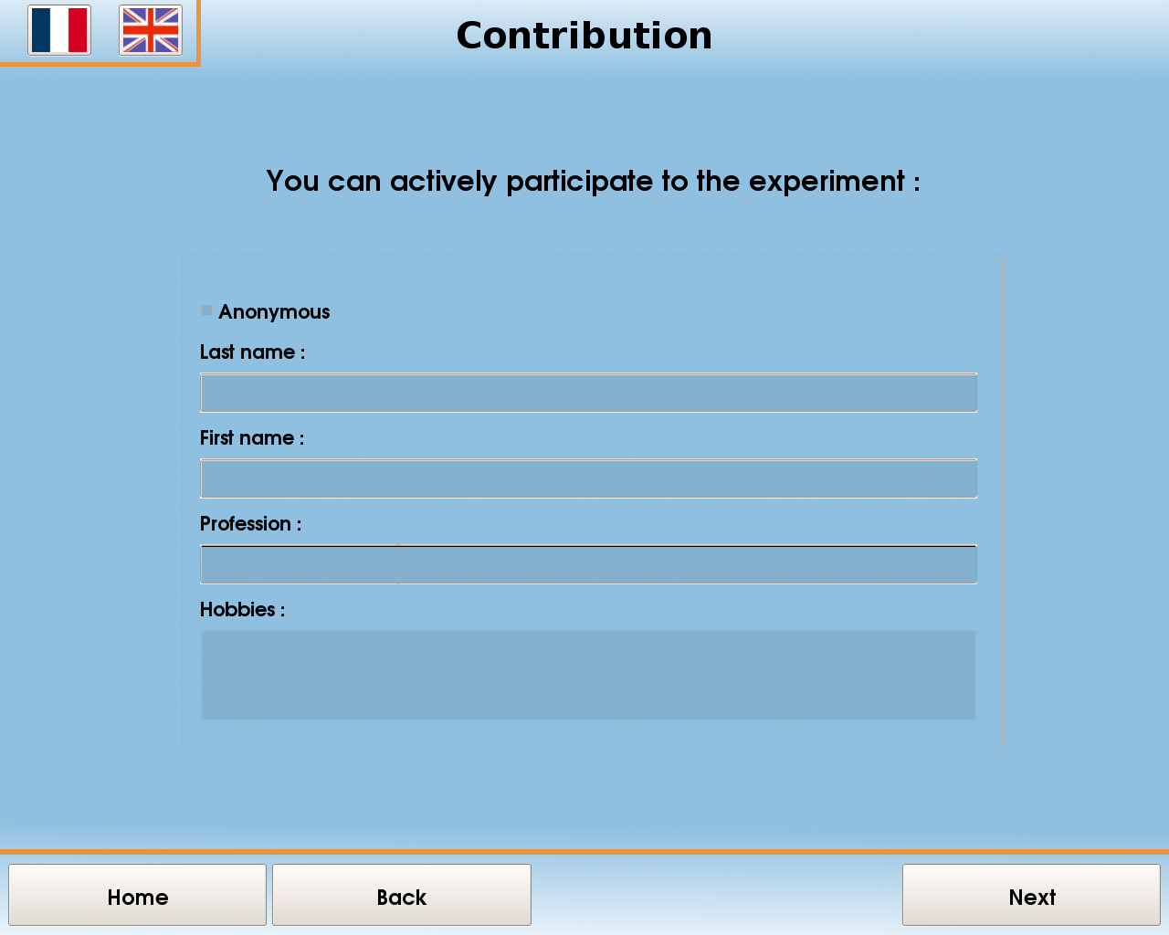 | 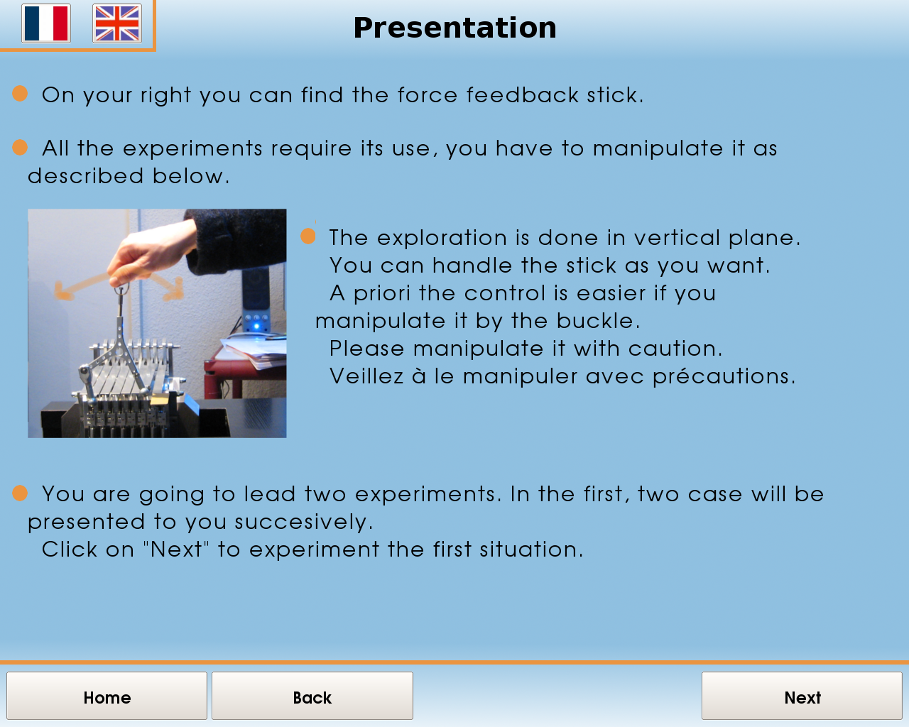 | 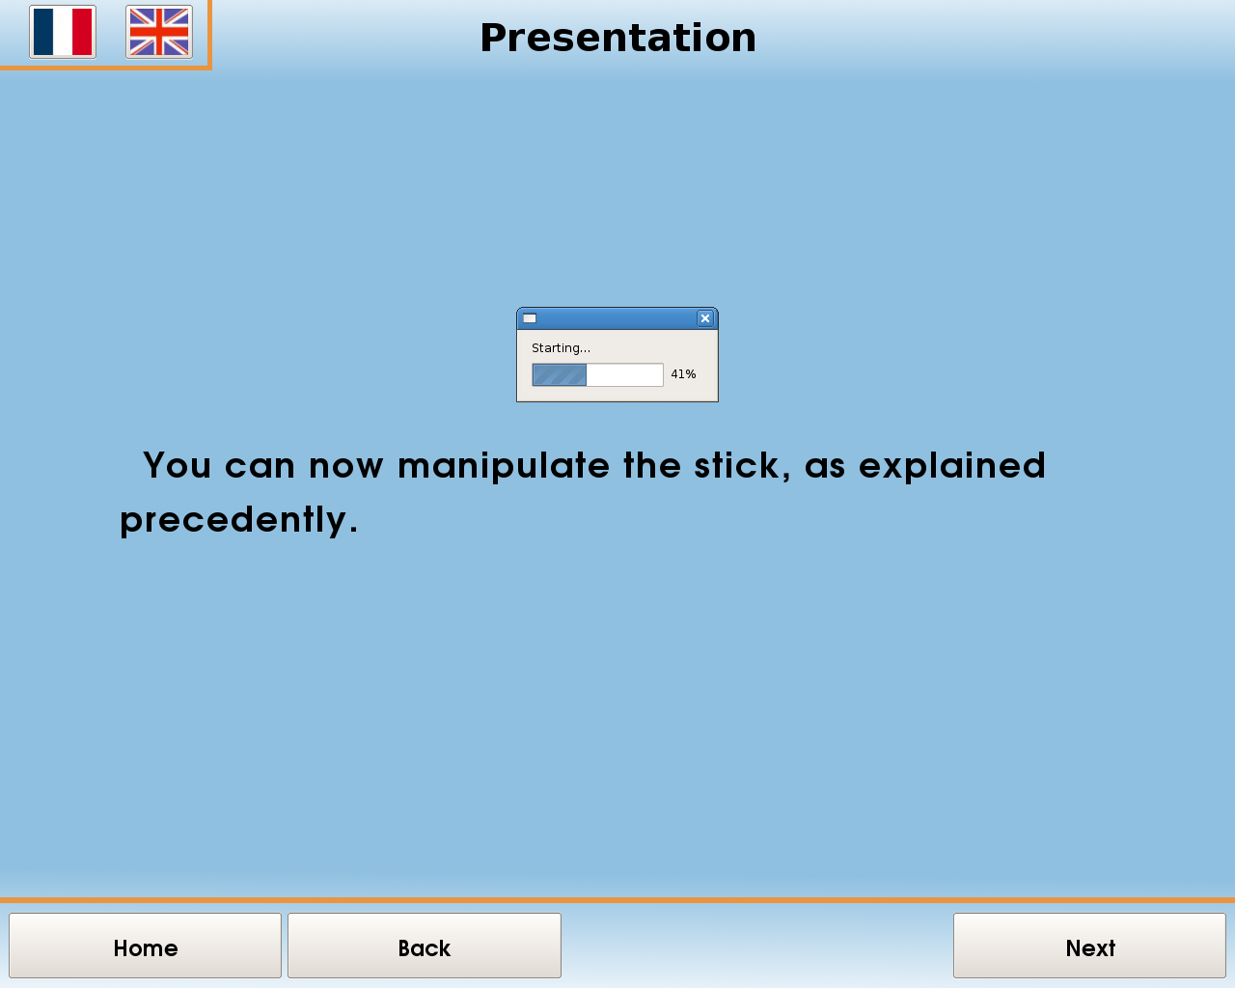
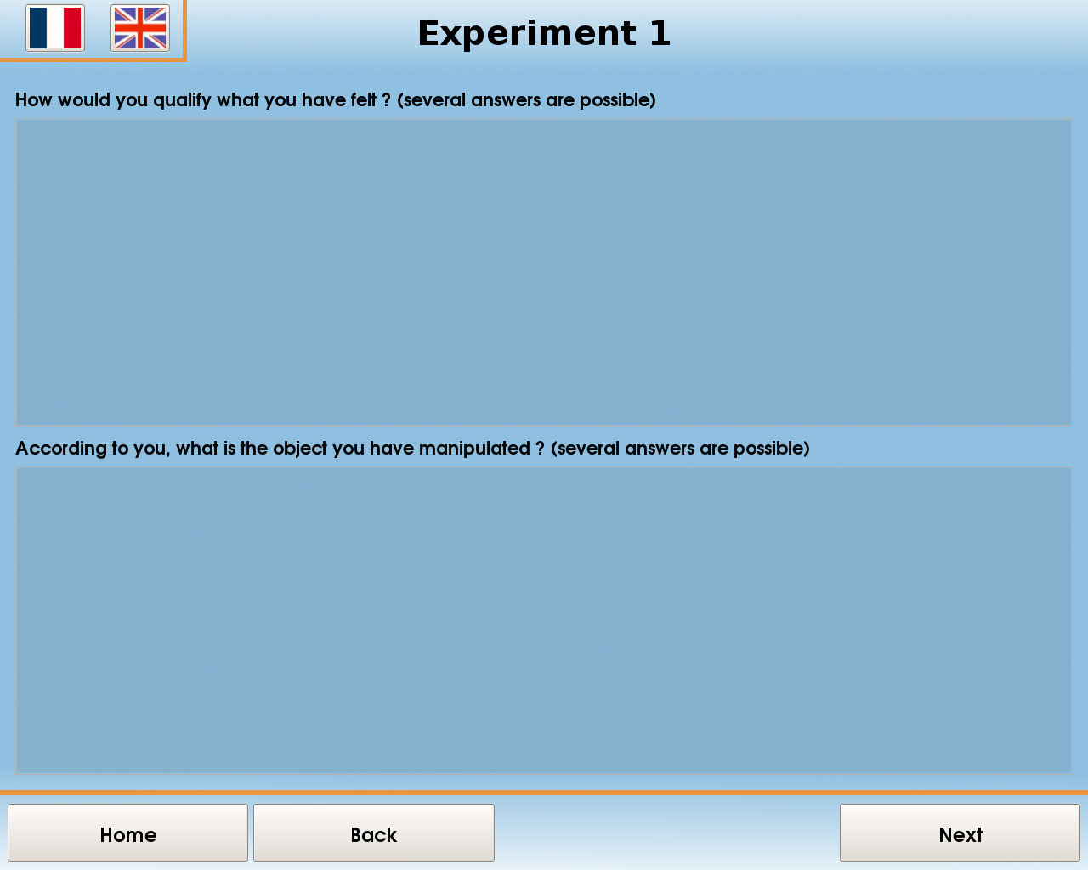 | 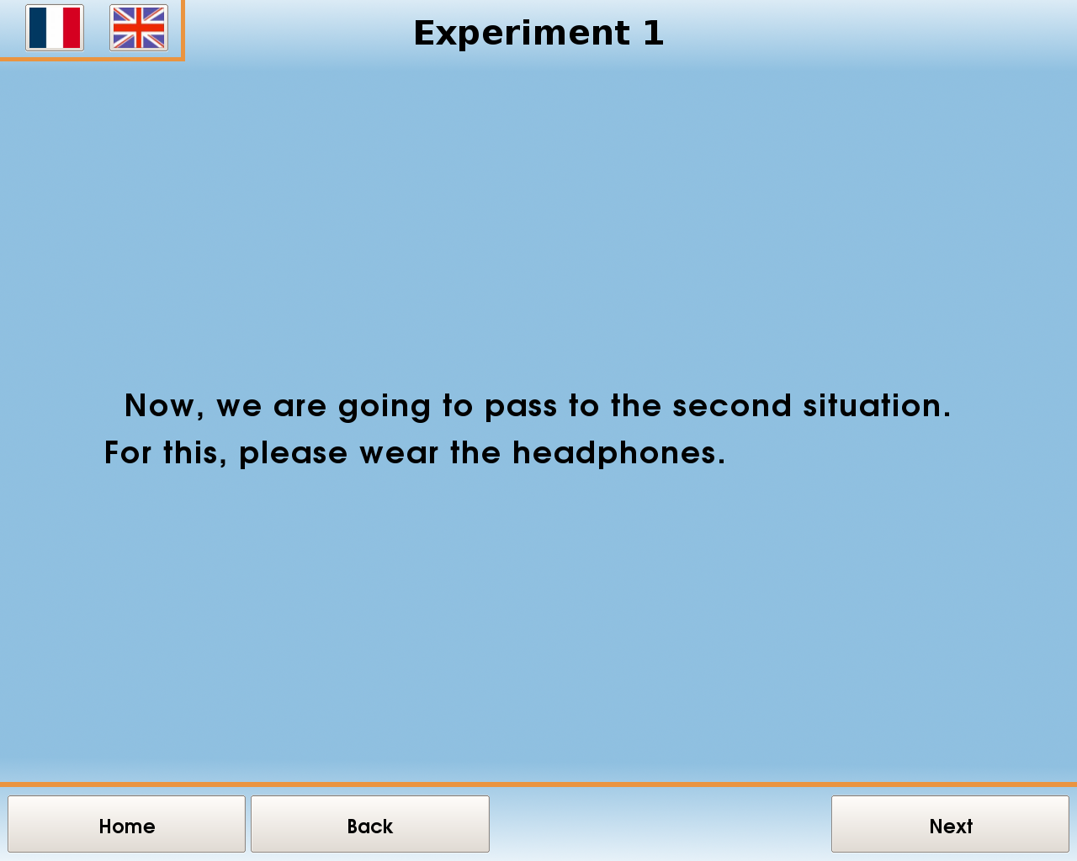 | 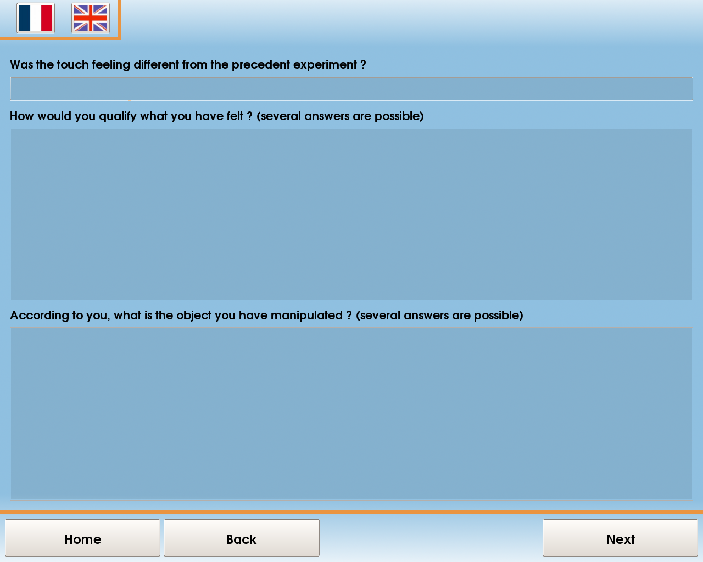
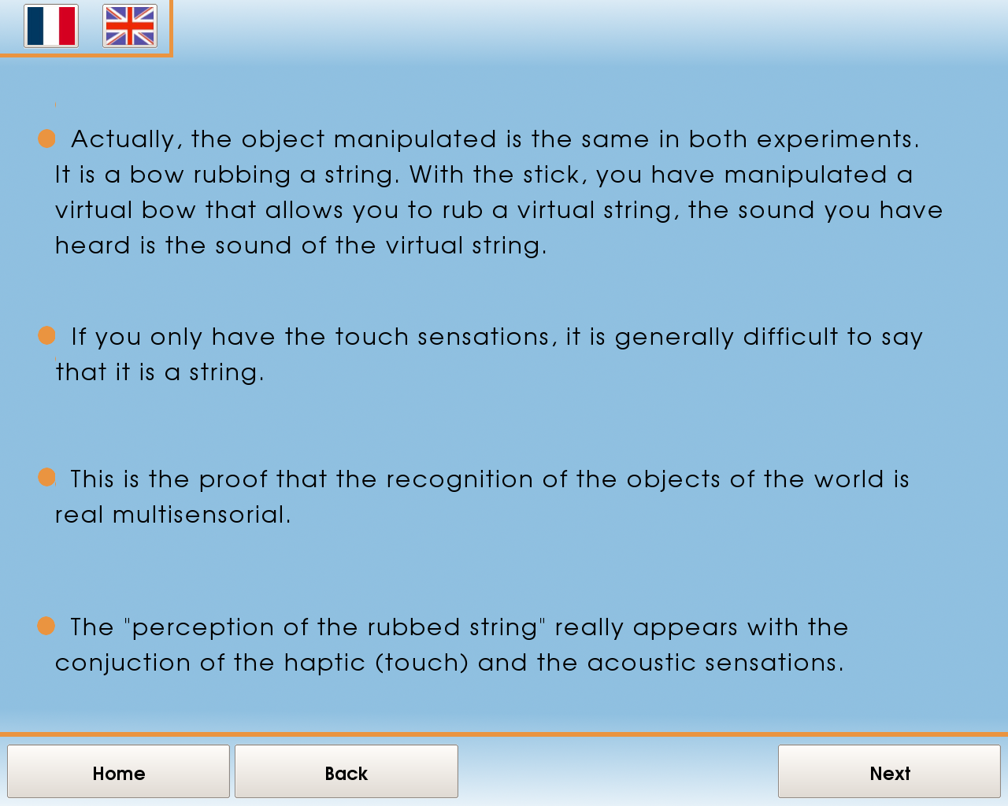 | 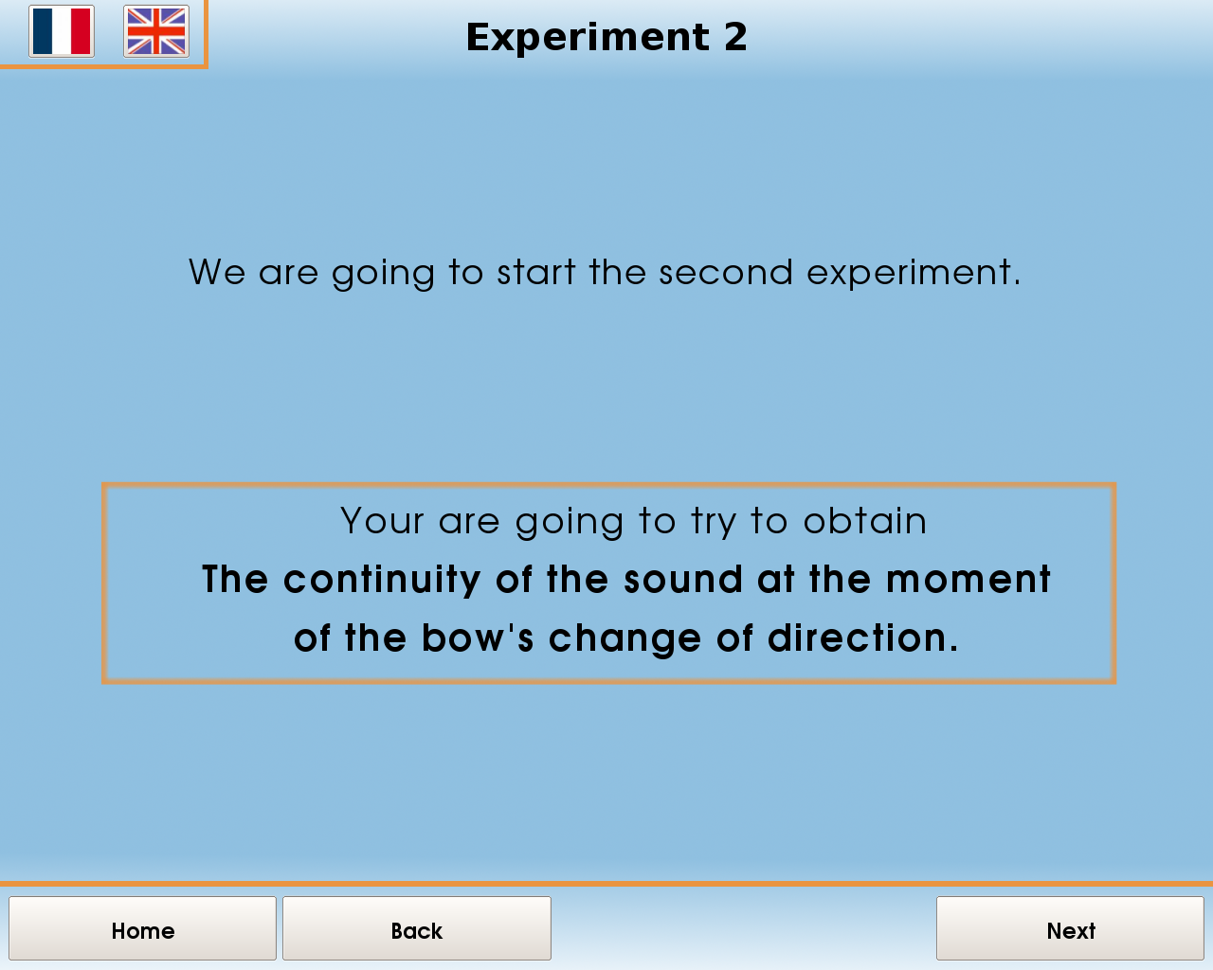 | 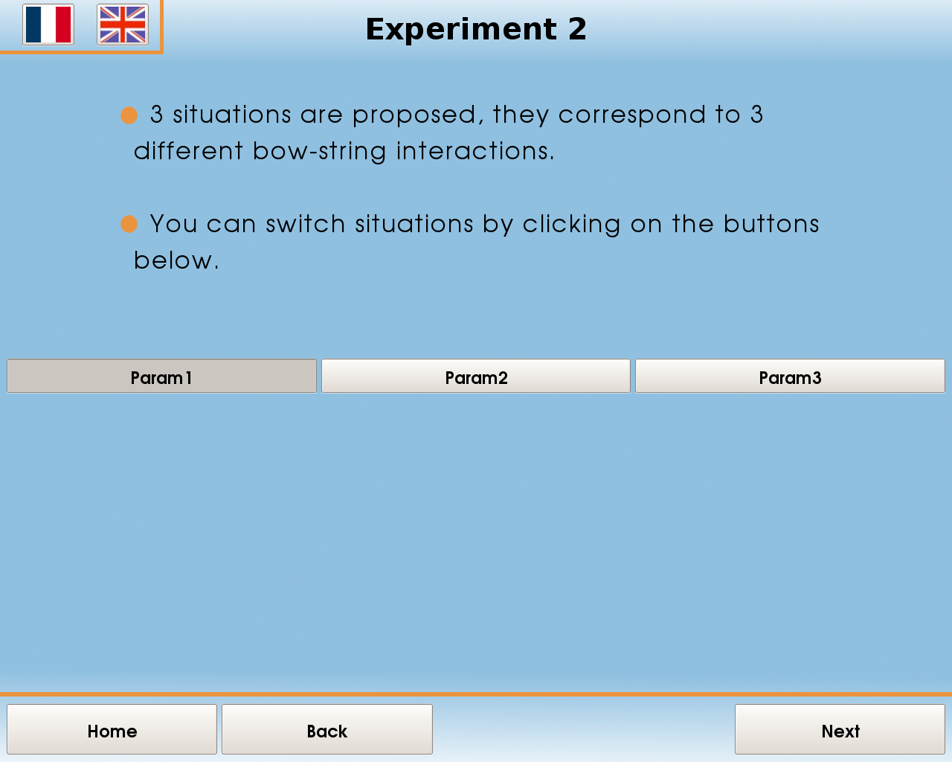
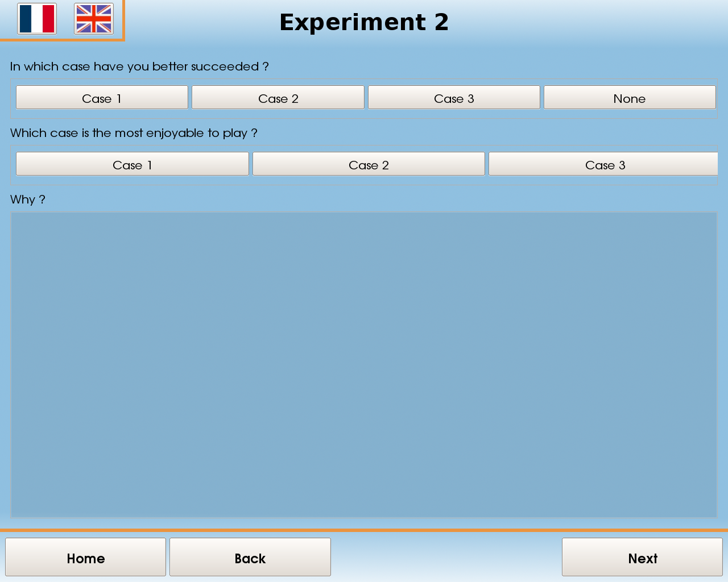 | 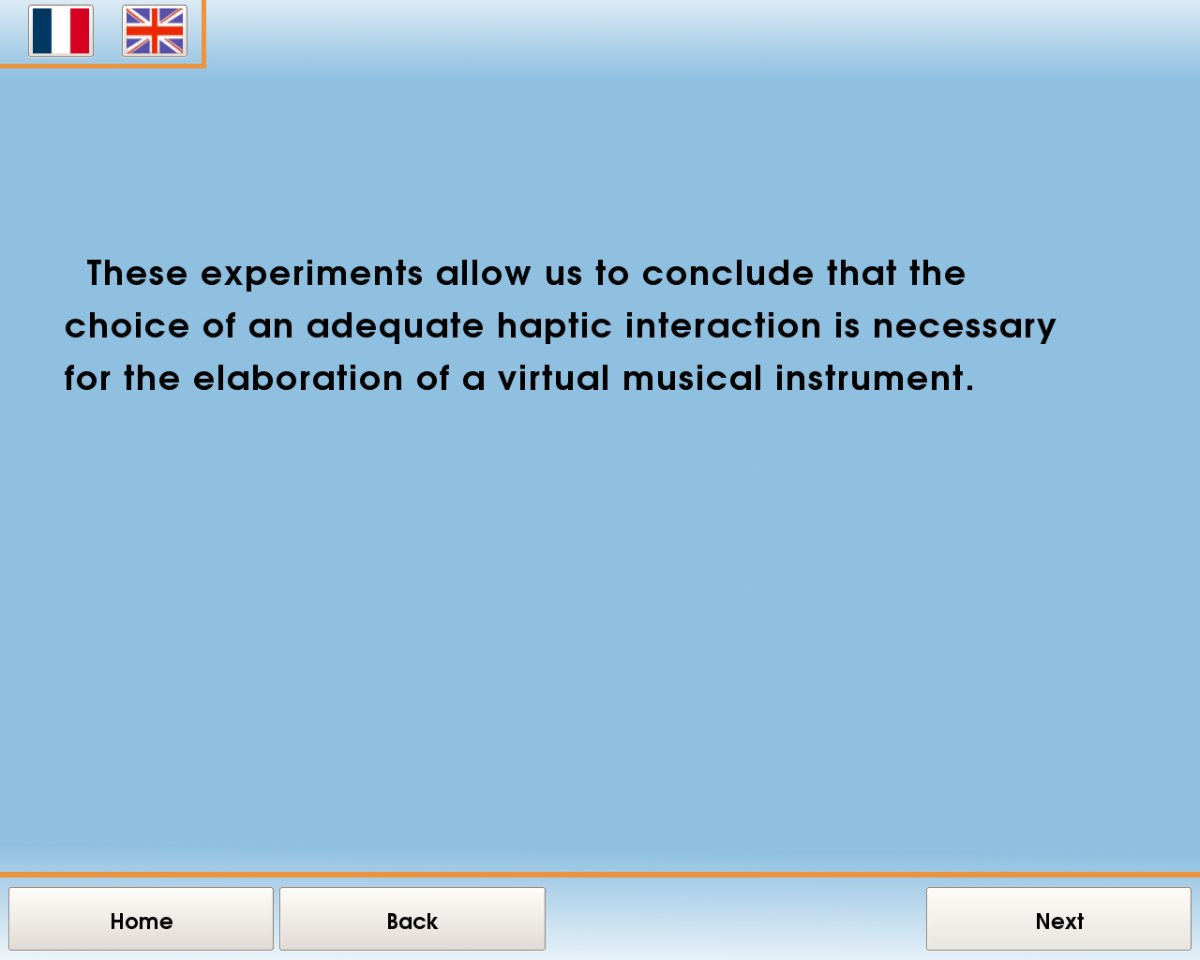 | 

1.5.2. Statistics at Enactive 07
All the answers of those who participated in the questionnaire during Enactive07 been recorded and constitute materials for future analysis and improvements.
We give below global statistics of the uses of the Ergotic Sounds EES during the five days of Enactive 07 “Touch the Future”.

 | Number of experiments with answers to the questions
 | Expe n°1 | Expe n°2 | Expe n°3
7/11/20 | 44 | 40 | 38
7/11/21 | 23 | 17 | 10
7/11/22 | 53 | 38 | 33
7/11/23 | 36 | 31 | 24
7/11/24 | 43 | 38 | 30
Total | 199 | 164 | 135

 | Duration of the experiment with answers to the questions
 | Expe n°1 | Expe n°2 | Expe n°3
7/11/20 | 0:39:01 | 1:01:39 | 1:27:08
7/11/21 | 0:41:24 | 0:12:04 | 0:16:42
7/11/22 | 0:51:15 | 0:51:01 | 1:31:05
7/11/23 | 0:55:18 | 1:27:21 | 1:07:40
7/11/24 | 0:36:07 | 1:20:45 | 0:54:12
Total | 3:43:05 | 4:52:50 | 5:16:47

 | Average duration of the experiments with answers to the questions
 | Expe n°1 | Expe n°2 | Expe n°3
7/11/20 | 0:01:06 | 0:02:07 | 0:02:36
7/11/21 | 0:02:30 | 0:01:23 | 0:02:01
7/11/22 | 0:01:26 | 0:01:46 | 0:02:55
7/11/23 | 0:02:04 | 0:03:05 | 0:03:03
7/11/24 | 0:01:25 | 0:02:47 | 0:01:59
Total | 0:08:31 | 0:11:08 | 0:12:34

1.6. References
Askenfeld et al. (1992) A. Askenfelt and E. V. Jansson. « On vibration sensation and finger touch in stringed instrument playing », Music Perception, 9:311–349,
1992. .

[Cadoz 1988] Cadoz C. "Instrumental Gesture and Musical Composition". Proceedings of International Computer Music Conference - Cologne 1988.
[Cadoz et al. 2000] Cadoz C., Wanderley M. (2000). “Gesture-Music” – in “Trends in Gestural Control of Music”, M. Wanderley and M. Battier, eds, pp. 71-94 -2000
Chafe. (1993) Chafe, C. “Tactile audio feedback”, In Computer Music . Computer Music Association, 1993.
[Clark et al. 1994] Clark Andy and Toribio Josepfa. “Doing without representating?” Synthese 101:1994 401-431. Kluwer Academic Publishers. 1994.
[Essl et al 2006] Essl G. and O’Modhrain S.. « An enactive approach to the design of new tangible musical isntruments ». Orgaised soubnds 11 (3). 285-296. 2006. Cambridge University Press.
[Florens 2002] Florens Jean-Loup. “Real time Bowed String Synthesis with Force Feedback Gesture”. Invited paper. Forum Acousticum. Sevilla. November 2002.
[Florens et al. 2004] Florens JL, Luciani A, Castagne N, Cadoz C. “ERGOS : a Multi-degrees of Freedom and Versatile Forcefeedback panoply”. Proceedings of Eurohpatics, pp356-360, Germany, 2004.
[Hunt et al. 2003] Andy Hunt, Marcelo M. Wanderley, and Matt Paradis. 2003. "The Importance of Parameter Mapping in Electronic Instrument Design." Journal of New Music Research, 32(4):429-440.
[Luciani et al. 2005] Luciani Annie, Florens Jean-Loup, Castagné Nicolas. From Action to Sound: a Challenging Perspective for Haptics. Proceedings of WHC 2005.
[Nichols 2002] Nichols C: “the vBow: a Virtual Violin Bow Controller for Mapping Gesture to Synthesis with Haptic Feedback” – in Organised Sounds – Leigh Landy ed. - Leicester, United Kingdom, 2002.
[O’Modhrain et al. 2000] O'Modhrain S., Chafe C.: “Incorporating Haptic Feedback into Interfaces for Music Applications” – in proceedings of ISORA, World Automation Conference, 2000.
[Rimell et al. 2002] Rimell S, Howard D M., Tyrrell A M., Kirk R, Hunt A – “Cymatic: Restoring the Physical Manifestation of Digital Sound using Haptic Interfaces to Control a New Computer Based Musical Instrument” – International Computer Music Conference, Sweden, 2002.
[Sinclair et al. 2007] Sinclair Stephen, Wanderley Marcelo M. « Defining a control standard for easily integrating haptic virtual environments with existing audio/visual systems ». Proceedings of NIME 07. New York, NY, USA.
[Luciani et al., 2007] Annie Luciani, Jean-Loup Florens, Damien Couroussé, Sylvain Marlière, Claude Cadoz. Ergotic Sounds: A new way to improve Playability, Believability and Presence of Virtual Musical Instruments. Proceedings of Enactive 07. Nov 2007. Grenoble
Varillo (1992) R. Verrillo. “Vibration sensation in humans”,
Music Perception, 9:281–302, 1992. .

Chapter 2: SoundDraw: Description of the Soundraw configurations, experiments, results and
analysis.

2.1 Drawing Gestures
AHEAD - Audio-Haptic Drawing Editor And Explorer for Education
Kirsten Rassmus-Gröhn, Charlotte Magnusson, Håkan Eftring
Certec, Design Sciences, Lund University, Lund, Sweden
kirre@certec.lth.se

Abstract – We present the final evaluation of an audio-haptic editor and explorer for virtual 2D relief drawings that allow visually impaired users to create and explore graphical images. The application has been developed in collaboration with a user reference group of five blind/low vision school children, and has undergone final evaluation during spring in 2007. The AHEAD application has been used to create material that has been successfully used in school work.

Keywords – Haptic, Audio, Education, Editor, Explorer, Blind, Low-vision

2.1.1. INTRODUCTION

Getting access to 2D graphics and especially computerized graphics is still a large problem for persons who are blind or have low vision. The traditional methods for enabling pupils access to graphic material in school is to make tactile drawings in advance, using swell paper, or to use prepared school material, so called “picture appendices” to the Braille books used in education. Furthermore, the reading of tactile pictures is a hard skill to master. Normally the teachers will describe the tactile pictures and sometimes help the pupils to feel the features in the pictures that are described by guiding their hands and fingers. A digital way of accomplishing a similar strategy is to use a touch screen with a tactile overlay, in which the pupil can point and click and then hear e.g. synthetic speech with descriptions of the marked feature in the picture[1]. However, this approach does not make it possible for the pupils to edit the drawings by themselves or make new drawings. Using a haptic display in combination with audio feedback is one way to solve those problems.
General guidelines to create and develop haptic applications and models are collected in [2]. Applications making practical use of non-spoken audio and force-feedback haptics for visually impaired people are e.g. applications supporting mathematical display [3], [4] & [5], games [6-8] and audio-haptic maps [6;9;10]. As described in [11] and [12], there are indeed people who are blind who have an interest in hand drawing. In [13], a CAD application is presented that enables users to create drawings with the help of audio and keyboard. In [14], a study on a haptic drawing and painting program is presented.

2.1.2. THE AHEAD APPLICATION

The Reachin 4.1
API for haptic interaction is needed to run the application, along with FMod Ex 4.04.30 used for non-speech sound and Microsoft SAPI 5.1 for speech synthesis. A PHANToM device is used for haptic feedback and control, and a mouse can be used for non-haptic control of the program.
The virtual environment consists of a virtual sheet of paper that is oriented in the vertical plane (standing up). The application can be used in two different modes: one for editing and one for exploring relief drawings.
In explore mode the users can explore text tagged relief drawings. The haptic image is produced as positive or negative relief. The drawing is represented on the screen as a grayscale image – a positive relief is seen as black, and a negative relief is seen as white. The paper color is grey. The users can select drawn objects by touching them with the PHANToM pen or hovering over them with the mouse cursor. When selected, the text tag for the line is spoken by the TTS engine. The mouse user can guide the PHANToM user by a pulling force that drags the PHANToM pen tip to the mouse cursor position. Similarly, the PHANToM user can drag the mouse cursor to the PHANToM position.

Figure 1 Two pupils collaborating using the AHEAD application making markings on a map of the Scanian region in Sweden
While in edit mode the PHANToM user can create and edit drawings. Drawing lines is done by pressing the switch when in contact with the paper. The mouse user draws while pressing the left mouse button. The PHANToM user can feel the lines while drawing. Drawn lines or figures (objects) can be manipulated in the different ways; moving, resizing, copying, pasting and deleting. Additionally, text tags for the lines and shapes can be changed, and shapes can be transformed into straight lines, rectangles or circles. The manipulation tools are fitted with feedback sounds designed to resemble a real world manipulation of similar nature. E.g. the copy function sound effect is a camera click.
Drawings can be saved and loaded with the application, using the applications customized MICOLE file format “.mcl”. The format includes the objects and the text captions for them. A “.png” import function is available. The files imported must be grayscale and exactly 256*256 pixels.

2.1.3. EVALUATION

The AHEAD application is in itself a multi-purpose application that can be used both for exploring prepared relief drawings and to create them in any school subject needed. Teachers and researchers have collaborated in planning and preparing a task and the material for a school subject fitting both the curriculum and the individual pupil. The tasks and the application have then been evaluated at school. Evaluation data has been collected with automatic logging of the user events (e.g. PHANToM and mouse movement samples, TTS events, file load events etc.), video recording and situated observation, and post-test interviews of pupils and teachers.
A. Participants
A reference group with 5 participants aged 11 to 17 years has participated in the entire project. The pupils are fairly well trained using the PHANToM, having used it at 3-6 reference group meetings, and have also participated in the iterative design of the AHEAD application. The iterative deign work is described in [15]. Four of the pupils participated in a qualitative evaluation with a prototype of the AHEAD application very similar to the final application. For the final evaluation, the teachers and teaching assistants of each pupil have participated in the planning and in the evaluation lesson at school. In three of the evaluation cases the pupil collaborated with a class mate, and in two cases the teaching assistant used the collaborative feature of the application to instruct the pupil.
Three of the five pupils in the reference group have residual vision. Only one of them used it while working with the evaluation task.

Visually impaired pupils and their previous experience of PHANToM use:
Pupil Age Residual vision Total PHANToM use experience prior to test
1 11 Used 30 minutes
2 12 Not used 30 minutes
3 12 No 1 hour
4 15 Not used 1 hour
5 17 No > 3 hours
B. Test procedure and tasks
The tasks were planned by teachers and researchers in collaboration. The teachers were invited to try the AHEAD application and to discuss possible subjects and tasks that would fit both the pupil and the curriculum. Since it is quite a challenge to try to envision the possible use scenarios for the teachers, the researchers had prepared a couple of demonstrators showing map use and geometry use, but the application was also showed in the mode where you can create a drawing from scratch.
The preparation of the material was done in different steps. First ordinary graphic material was prepared. In 3 of the cases this implied downloading and using some graphical material as base material, e.g. free maps on the Internet. For the school yard, the map was made from scratch, visiting the school yard and making first a hand drawing and then a drawing in Adobe Illustrator. The graphics were converted using Adobe Photoshop to line drawings in grayscale, and then inverted to make the lines white (in the AHEAD white lines are rendered as negative relief). The graphic images were also cropped to 256*256 pixels. Then the prepared grayscale files were loaded into the AHEAD application as a background picture and the outlines and figures that were important were filled in using the edit mode and text tagged. When the copying part was done, the background file was removed, and what remained was the important features with text tags that the text-to-speech (TTS) system can read.

Task for pupil 1. For pupil 1 the test was conducted in a fifth grade class in the subject geography. The learning task chosen was to learn to interpret maps and learn about the geography of the European part of Russia. The task for all pupils in the class was to draw a simplified map of the country, featuring the most important parts such as mountains, rivers and major cities. The sighted pupils worked with a regular map book and an outline map where they were supposed to fill in the important features.

Figure 2 Map of the European part of Russia. All borders, cities (circles), the river Volga and the major lakes have text captions spoken by the TTS.
The test setup for the visually impaired pupil consisted of a PHANToM OMNI, a laptop running the program and acting as screen and keyboard for the pupil. The teaching assistant used the mouse for guiding and showing the pupil features on the map when needed.
The AHEAD application was loaded with a customized map of the European part of Russia (see figure 2). The pupil used this map as a substitute for looking in the map book through the CCTV, which is the way the pupil usually performs the task, inducing problems such as glare and problems with overview. The pupil had a tactile map of the outlines of European Russia to make a simplified map from, using markers and crayons to draw and write on the paper map.

Task for pupil 2. For pupil 2 the test was conducted in a sixth grade class in the subject geography. The learning task chosen was to learn to interpret maps and learn about the geography of South America. The task in the lesson for all pupils was to make a simplified map by hand of the continent, with major mountain ranges, lakes, countries and capitals.
For this type of task, the visually impaired pupil would usually work with the teaching assistant, who would describe the geography verbally with a tactile map for reference. On the tactile map used there would be code letters that marked important features, and the pupil would usually type the code letter and the names that the code letters marked into the computer.

Figure 3 Map of South America. All borders, capitals (circles) and the surrounding oceans have text captions than are spoken by the TTS.
At the test session, however, the pupil was instead instructed to work with a sighted classmate, collaborating on the task using the AHEAD application. The classmate would make the markings on the tactile map, while the visually impaired pupil was exploring the map (see figure 3) and telling his class mate what to write down.

Task for pupil 3. Pupil 3 was the only one who did not use the AHEAD application in class. Instead it was used for navigation training. The pupil, who does not have any residual vision, is normally integrated in a sixth grade class with sighted children. Usually the navigational training would be performed by using a tactile map and by walking repeatedly the paths that the pupil needed to learn. At the test session the pupil instead used the AHEAD application for the training.
As the test task a kind of treasure hunt was implemented. 3 detailed maps of the path from school to the bakery were prepared with the AHEAD application. The bakery was selected as the goal of the exercise, since all the sighted pupils used to go there and the visually impaired pupil had expressed a wish to be able to go there too.
The pupil was to explore every map step by step. When the first map (see figure 4) was explored and the treasure on that map was found and the pupil felt confident enough to remember the route, the pupil was supposed to travel by foot unaided by the assistant to the treasure in the real environment. The teaching assistant followed and was allowed to give verbal hints referring to the map, but the assistant was instructed not to help in other ways (by leading the pupil for example). After the pupil succeeded with finding the first treasure, the other 2 maps were explored. Because the time was running out, both maps were explored and then the next treasure was searched.

Figure 4 Map of the school yard of pupil 3. All permanent ground obstacles were modelled and the details described by the text captions spoken by the TTS.
Task for pupil 4. The test for pupil 4 was conducted in a ninth grade class in the subject mathematics. The learning task in the particular lesson was to practice using geometrical mathematical language, i.e. words like “rectangle”, “sphere”, “angle” and “diagonal” to describe a composite geometry figure to a fellow pupil. The sighted pupils were instructed to use paper, pencil and a ruler, and the visually impaired pupil and a fellow pupil were instructed to use the AHEAD application. The test setup consisted of a laptop running the program and acting as screen and keyboard for the sighted pupil who also was using a mouse for input. The visually impaired pupil had a separate keyboard attached to the same computer, a screen, headphones and the PHANToM OMNI. Half of each screen was blinded by a piece of
cardboard to prevent the pupils from seeing the drawing the other person made.
The AHEAD application was loaded with a file with a subtle grid in positive relief, and a middle line with the spoken caption “Stop, middle line” (see figure 5). The pupils were supposed to use one part of the virtual paper/screen each to draw on and the middle line was not to be crossed until the last phase of the task. There were three parts to the task; first, one pupil would design a composite figure in the drawing application (without showing it to the other pupil); second, the same pupil would describe the figure to the other pupil who would try to make a copy based on the description; third, the pupils would together compare the copy to the original figure.

Figure 5 The left picture shows the empty grid for the mathematic task. The right picture shows a picture from the test (with the grid removed for better clarity).
Task for pupil 5. The test was conducted in a high school second grade class in an aesthetic program. The learning task was to, on the basis of an image of a traditional Shakespearean theatre (i.e. The Globe), place the actors on different parts of the stage and balcony etc. in every scene of a Shakespeare play which they had read in advance. The image was marked with the different parts of the theatre – e.g. formal stage and balcony.

Figure 6 A simplified drawing of a Shakespearean theatre. The major parts such as pillars, main stage, balcony, trap door, valves etc. were marked with captions.
The pupils worked in pairs and were allowed to spread out anywhere at school during the group session. The blind pupil did not want the classmates (except the collaboration partner) to see the test arrangement, therefore a small room adjacent to the classroom was used for the AHEAD test.
The AHEAD application was used to load prepared drawings of the Globe Theater. There were 4 different files with stage information to choose from. One drawing was a simplified variant of the tactile picture that the assistant had previously prepared for the pupil. There was also a simplified cross-section from above and then a view in front of the stage (see figure 6). Both the latter drawings were also included into one file with somewhat smaller details.
The pair of pupils could choose freely between the files, using the one that suited them the most. Pressing a shortcut on the keyboard would start a standard Windows file load dialog that was supported by JAWS to enable text-to-speech outside the AHEAD application.

2.1.4. RESULTS

Most of the data collected is still being analyzed, and in this paper we only report the overall results that do not depend on the more detailed analysis.
The first thing to note is that in all the above described test cases the pupils were able to carry out the test tasks, and according to the teachers they also performed well. Four of the pupils were very pleased with the applications functioning, and would like to experience such an interface for other school subjects and/or for leisure activities. One pupil did not like to use the AHEAD application and would rather do the tasks the usual way. This particular pupil also has some problems with fine motor skills, which makes handling the PHANToM device harder. Even so, also this pupil was able to complete the tasks.
Two of the students that liked the applications commented particularly that the AHEAD type of environment made 2D graphical material more accessible compared to the tactile graphics that they normally used (made with swelling paper).
The fact that the AHEAD environment allowed for collaboration, by giving a mouse user and a PHANToM user access to the same material was generally appreciated. The guiding function where the mouse user guided the PHANToM user was well liked by two of the students while one did not like being guided at all. The guiding function where the PHANToM user guided the PHANToM was not used except by accident.
Some qualitative results concerning the usability of the application have been collected. There is e.g. the case of learning geographical names that is a challenge when using only text-to-speech systems. A Swedish TTS engine simply will not pronounce e.g. “Buenos Aires” or “Georgetown” correctly, and even if it did it might be hard to learn the names. Finally, pupil 3 who performed the navigational task would rather have the map displayed in the horizontal plane, since it would help understand the directions better.

2.1.5. . DISCUSSION AND CONCLUSIONS

In general the results of this tests show that programs like the AHEAD application could be a useful complement to the materials already used by visually impaired children at school. Despite the single point haptic interaction provided by the PHANToM, pupils found that the AHEAD application provided good overview of the displayed 2D graphics, and two pupils in particular commented that this was actually better than the raised line images normally used (despite the fact that these can be explored by all fingers simultaneously).
The fact that the environment allowed for both a mouse user and a PHANToM user to have access to a common workspace was seen to be important, and to increase the usefulness of the application. The guiding function where the mouse user guided the PHANToM worked well when the mouse user used a guiding motion to lead the PHANToM user to a target or show a shape. The result of the guiding depended on how the mouse user used it – and the test results indicate that one should advice the mouse user on how to use the guiding efficiently. Still, it is important to note that some users may not like being guided (these results agree with the observations made in collaborative haptic environments with multiple PHANToMs [16]).
Also, the usability problems observed suggests that a Braille display should be connected to the system and that the user should be able to change the orientation of the virtual paper.

2.1.6. . FURTHER WORK

The described evaluations are aimed at foreseeing use scenarios in school in a not too distant future. There are still challenges, aside from the problem of expensive hardware and software. The next step will be to investigate if and how a teacher or teaching assistant will be able to use the AHEAD software in school, preparing the material and using it without technical help.

2.1.7. REFERENCES
[1] S. Landau and L. P. Rosenblum, "Results of the Talking Tactile Tablet Authoring Tool Contest," CSUN 2005 - Electronic Proceedings, 2005.
[2] C. Sjöström, "Non-Visual Haptic Interaction Design - Guidelines and Applications." Ph D Dept. for Design Sciences, Lund University, Faculty of Engineering, 2002.
[3] W. Yu and S. A. Brewster, "Comparing Two Haptic Interfaces for Multimodal Graph Rendering," Florida, USA: 2002.
[4] W. Yu, K. Kangas, and S. Brewster, "Web-based haptic applications for blind people to create virtual graphs," Haptic Interfaces for Virtual Environment and Teleoperator Systems, 2003. HAPTICS 2003. Proceedings. 11th Symposium on, pp. 318-325, 2003.
[5] L. Bussell, "Touch Tiles: Elementary Geometry Software with a Haptic and Auditory Interface for Visually Impaired Children," 2006, pp. 512-515.
[6] R. Iglesias, S. Casado, T. Gutierrez, J. I. Barbero, C. A. Avizzano, S. Marcheschi, and M. Bergamasco, "Computer graphics access for blind people through a haptic and audio virtual environment," Haptic, Audio and Visual Environments and Their Applications, 2004. HAVE 2004. Proceedings. The 3rd IEEE International Workshop on, pp. 13-18, 2004.
[7] C. Magnusson, K. Rassmus-Gröhn, C. Sjöström, and H. Danielsson, "Navigation and Recognition in Complex Haptic Virtual Environments - Reports from an Extensive Study with Blind Users,". S. A. Wall, B. Riedel, A. Crossan, and M. R. McGee, Eds. Edinburgh, UK: 2002.
[8] C. Magnusson and K. Rassmus-Gröhn, "Audio haptic tools for navigation in non visual environments," 2005.
[9] C. Magnusson and K. Rassmus-Gröhn, "A Virtual Traffic Environment for People with Visual Impairments," Visual Impairment Research, vol. 7, no. 1, pp. 1-12, 2005.
[10] O. Lahav and D. Mioduser, "Multisensory virtual environment for supporting blind persons' acquisition of spatial cognitive mapping, orientation, and mobility skills," ICDVRAT '02 - Electronic Proceedings, 2002.
[11] J. M. Kennedy, Drawing and the Blind - Pictures to Touch. New Haven and London: Yale University Press, 1993.
[12] Art Beyond Sight Art Education for the Blind, Inc. and AFB Press, 2003.
[13] H. M. Kamel, "The Integrated Communication 2 Draw (IC2D)." Ph D Electrical Engineering and Computer Sciences Department, University of California, 2003.
[14] C. Hansson, "Haptic Drawing Program." Master Design Sciences, Lund University, Faculty of Engineering, 2003.
[15] K. Rassmus-Gröhn, C. Magnusson, and H. Eftring, "Iterative Design of an Audio-haptic Drawing Application," CHI 2007, 2007.
[16] E.-L. Sallnäs, "The Effect of Modality on Social Presence, Presence and Performance in Collaborative Virtual Environments." Doctoral Numerical Analysis and Computer Science, KTH, 2004.

2.2. Soundraw – a proposed experimental protocol

2.2.1. Experiment: Method and procedure.

The aim of this protocol was to design a way of measuring the effect of auditory feedback on the capacity of drawing a circle, in particular the capacity of correctly closing the circular figure without visual feedback.

In this protocol, 4 conditions are tested:
- Blindfold + sound
- Blindfold No sound
- No Blindfold No sound
- No Blindfold + sound
Each subject executes 100 trials for 1 of the experimental conditions.
The trials are recorded and in particular the distance between the starting point and the point of arrival is recorded and measured.
For each subject the following information is extracted: evolution of the distance between starting and ending point through the 100 trials.

2.2.2 Proposed analysis of results
The results of subjects tested under the same conditions are grouped in a curve representing the mean distances obtained for each of the 100 trials thus obtaining 1 mean curve for each condition.
It is expected that performances in condition 1 and 2 will be enhanced by training, hence that they will improve through trials. It is also expected that no significant improvement will be recorded for conditions 3 and 4.
The curves obtained in different conditions will be compared. ANOVA will be performed for comparing the outcomes for the different conditions for each trial.
It is hypothesized that for each trial performances in condition 1 will be better than performances in condition 2. It has to be ascertained whether improvement increases at a different rate in condition 1 and 2.

2.2.3. Recommended Experimental setting

The experimental apparatus is as follows:
Hardware : Fujistsu Siemens PC Stylistic Tablet, Penabled Wacom running Windows software
Sony video cam
Software : Max Msp Runtime, running Maurizio Giri © patch

The recommended experimental environment is as follows:
Room with door and windows closed and minimized environment sounds.
Optimal visibility.
Tablet on a desk in fixed position.
Adjustable chair.
Video camera for recording the sessions fixed and pointed to the tablet/hand.
Only the experimenters and the subject are present in the room.

2.2.4: Detailed Experimental Procedure

On arrival in the experiment room, the participant is read the following text:

“You will be asked to try out some new software for drawing. During several trials you will be asked to do the same thing: to draw a circle.
At the end you will be asked to fill-in a short and anonymous questionnaire with your personal data.”

(The participant is then shown the device)

“This is the device to be tested. Sit comfortably. The position of the tablet is fixed: do not move it. Become familiar with the hardware and software device through half a dozen free trials with no recording of the results. During the recording you will wear a blindfold*.
Do not press the pen too much on the tablet.
Make a little pause between one trial and one other.”

Once these warm-up trials are complete, the main body of the study commences:
(Experimenter 1 then starts the procedure for recording the session and Experimenter 2 switches the video camera on)

“We now begin to record. You will draw 100 circles one after the other. I recommend you to stop a little while between one trial and one other. I will stop you at 100. Wear the blindfold and start*.”

(At the end of the session, Experimenter 1 stops and writes notes on the session. Experimenter 2 stops the video camera)

« It is over. Now you can fill in the questionnaire.
Thank you for your participation”

2.2.5: Additional comments

While this protocol has been tested in pilot, no data has been recorded. The application developed for the experiment was, however, presented at the ‘Touching the Future’ exhibition at Enactive07.

Chapter 3.
Musical Performance: Description of the installation, of the experiments conduced with the installation, analysis of the results and of the relevance for the two aims described
In the objectives.

Note: No material has yet been received for this chapter of the Deliverable, responsible is Barbara Masarini at Uni. Je.

Chapter 4. PebbleBox:

  - Introduction

This chapter presents a progression of studies that explore concepts of believeability, using as their experimental platform several versions of the PebbleBox. In section 4.2., Elena Pasquineli develops a theoretical basis that motivates the design of an initial protocol for testing believeability. Section 4.3. presents some preliminary findings from a study run in Grenoble in February 2007 that utalised three different enstantiations of the PebbleBox and section 4.4. presents a recent study by Issartel and O’Modhrain that steps back to probe in more detail certain aspects of behaviour that were observed during the Grenoble studies.

4.2: Believability and the Pebble Box
Elena Pasquinelli
Institut Jean Nicod

The Enactive Network has recognized the necessity of elaborating an operational, minimalistic, and ethically correct characterization of the notion of believability.
JRA-RD1, Task 2 has assumed this objective, together with the one of extracting pragmatic indications for the enhancement and evaluation of believable experiences.
EES5.4, dedicated to the implementation and the conduction of experimental activities with the Pebble Box, has been chosen as an exemplary study-case for testing the characterization of believability, with relative pragmatic indications, that has been proposed in the frame-work of JRA-RD1, Task 2 (see JRA-RD1, Task 2 (D.RD1.1)).

Theoretical frame-work
Summary: Believability in non-mediated conditions can be characterized as the susceptibility to raise beliefs that can be taken for true, while believability in mediated conditions is characterized by the susceptibility to raise imaginings that put the user in the condition of behaving (at the emotional, perceptual, motor and cognitive level) in the way auspicated by the authors of the experience.
The appropriateness of the users’ responses to the contents and to the context of the experience is then the meter for evaluating the level of believability. Cognitive sciences research on perception and cognition indicate coherence and expectations as the main factors that determine whether an experience will be believable or not.

Believability is a declared objective for experiences with new media, such as virtual reality and mixed reality systems (Kim, 2004; Papagiannakis, et al., 2005; Nass, 2000; Mateas, 1997; Gratch, 2005; Loyall, 1997; Reilly, 1996; Bates, 1994; Bates, 1991; De Rosis, et al., 2003; Matheson, et al., 2003; Poggi, et al., in press; De Rosis & Castelfranchi, 1999; Pelachaud & Bilvi, 2003; Pelachaud & Poggi, 2001; Rizzo, et al., 1999; Rizzo, 2000; Egges, 2002; Egges, et al., 2004; Magnenat Thalmann, et al., 2005; Ortony, 2003, Thomas & Johnson, 1984). The term is habitually referred to virtual or fictional characters. A great importance is hence accorded to the representation of emotions and rich personalities (Nass, et al., 2000; Mateas, 1997; Gratch, 2005; Loyall, 1997; Reilly, 1996; Bates, 1994; Poggi, et al., in press; De Rosis & Castelfranchi, 1999; Pelachaud, 2001, 2003; Ortony, 2003; Thomas & Johnson, 1984). Whenever the illusion of life is intended as the illusion that virtual agents move by their own will rather than being guided by an external will, movement is considered to be another relevant enhancing factor for believable characters (Egges, 2002; Egges, et al., 2004; Magnenat Thalmann, et al., 2005).
Also traditional story-telling media (cinema, radio, theater, books) deal since long with the goal of proposing audiences with believable fictional worlds, characters and events, and this effort has given rise to related concerns on the side of philosophers. The debate is especially active since Radford’s initial statement of the so-called ‘paradox of fiction’ in 1975 (Radford, 1975): how can we be moved by the fate of Anna Karenina? Do we need to believe in the existence of fictional or virtual characters in order to experience emotional and related behavioral reactions? And, can we be mistaken about the nature of the mediated experience, so as that we take it for real (Carroll, 1990; Walton, 2001; Currie, 1990)?
Other considerations about believability come from non-fictional media, and mainly prevent from confusing reality with fiction, so as to create ethical side-effects related to fraud, hoax and gullibility (Thornton, 2000; Steele & Black, 1999; NASW, 2006; NPPA, 1999; Hansen, 2007; RTNDA, 2000; ASNE, 1999; EthicNet, 2002).
However, no characterization of believability exists that takes into account all of these different debates and that fulfills the following requirements:
- be ethically correct, in the sense of not violating ethical codes of media communication
- be minimalistic, in the sense of being common to different media, both new and traditional, such as virtual reality and cinema, and in the sense of showing the connections and differences between believability in mediated and believability in non-mediated conditions
- be operational, in two senses: in the sense of making reference to behaviors and experiences that can be observed and measured objectively (not only through questionnaires and first person assessments). And in the sense of directly containing indications for producing believable rather than unbelievable experiences.
Our characterization aims at fulfilling these requirements and can be factored into the following points:

- Believability in virtual and fictional contexts consists in the susceptibility to raise imaginings that put the user in the condition of behaving in accord with the prescriptions provided through perceptual and narrative hints by the authors of the experience, and with the constraints represented by the structure of the medium.
Representations mediated by virtual reality devices or other media are substantially different from real things. It is then plausible that believability will have different conditions in the case of representations and in the case of reality.
In normal cases, for instance, one does not notice that the real world is going on in a believable fashion: the real world is trivially believable. This is not true for representations, where producing believable virtual or fictional worlds is a precise aim for designers and a desired condition for users. However, in some situations even the perceptual experience of the real world can appear bizarre to the perceiver, i.e. when a paradox is perceived, when a conflict is experienced or when experience is inconsistent with acquired knowledge. These situations are associated with a reaction of surprise, which is more or less strong depending on the contents of the experience and on the attitude of the perceiver (Castelfranchi, 2003). Surprise has an epistemic value, since it has the effect of alerting perceivers that there must be some error in the perceptual experience (that cannot be believed) or in past beliefs. Also, appropriate responses to the environment are suspended by a sort of paralysis of actions (Stein & Meredith, 1993). It is hence when expectations are unfulfilled or coherence is violated that the problem of believability arises. In these circumstances, one is not disposed to form a (true) belief and judges the experience as un-believable. Conversely, the judgment of believability, in the experience of the real world, corresponds to the condition of being disposed to hold beliefs susceptible of being true.
Is believability in virtual and fictional contexts the same thing than believability in real ones? Important differences subsist between purely narrative media such as books and perceptual but not interactive media such as cinema (Casati & Pasquinelli, 2005). In spite of these differences, virtual reality is a form of representation as story-telling films or books (Biocca, Kim, Levy, 1995; Kim & Biocca, 1997; Lessiter, et al., 2001; Lombard & Ditton, 1997, 2000; Loomis, 1992; Riva, et al., 2003; Steuer, 1995; Vorderer, et al. 2004), because virtual worlds “extend our epistemic access to things in the worlds; if they are reliable, representations give us information about things when those things are not directly accessible to us” (Currie, 1995, p. 49). Then, virtual reality systems share more affinities with other representational media that provide information in absence of the thing, than with devices that help accessing the things themselves (such as lenses, or tele-operation that present and do not represent, Currie, 1995).
As in the case of believable or unbelievable experiences in the real world, violations of coherence and the frustration of expectations have a dramatic effect upon believability in fictional and virtual worlds, because they make it difficult for users and spectators to interpret what is happening (Bordwell, 1985; Davidson, 1984). Nevertheless, reactions of surprise are largely exploited by filmmakers. This fact depends on the very nature of fictional and virtual experiences, and in particular on the fact that fictional and virtual worlds are not evaluated in terms of beliefs.
An influential current in philosophy states in fact that fictional and virtual worlds raise in the audiences and users an activity of imagination and that the appropriate reaction to worlds of fiction and representations is rather the production of imaginings than the production of beliefs (Walton, 2001; Currie, 1995). This activity shares a number of analogies with the activity of believing, at the point that it can be considered as a form of simulation of having beliefs: the connections within beliefs are preserved, but motor and other behavioural responses are normally inhibited by the awareness of the fictional, mediated nature of the experience (Currie, 1995). Emotional responses can be preserved (with the sole inhibition of their motor counterpart, Currie, 1995) or they can be make-believe emotions (Walton, 2001), in analogy with the make-believe character of the activity of imagination which is generated by the representation of worlds of fiction. On the basis of their common representational nature, the same considerations that are valid for cinema and other worlds of fiction biased by traditional media can be extended to virtual worlds. Yet, movies activate perceptual performances of identification and recognition, of multimodal integration between sound and image, while virtual worlds permit users to perform motor actions and interactions with virtual places, objects and agents as well. In the case of virtual reality some of the motor consequences of imagining are hence allowed. As emotional and perceptual behaviours, even motor performances are guided by specific perceptual hints and of narrative elements that authors suitably manipulate in order to prescribe users behave in certain ways rather than in others (Bordwell, 1985). Other constraints directly come from the medium and its specific characteristics: the ‘passive’ nature of cinema inhibits motor responses, while virtual reality systems permit motor responses within the limits defined by the structure of the virtual reality system itself.
Following this approach, believability in virtual contexts is characterized as the susceptibility to raise imaginings and that put the user in the condition of behaving in ways that are prescribed by perceptual and narrative hints that correspond to the intentions of the authors of the experience, and constrained by the structure of the medium. This approach to believability is opposed to the idea that virtual reality and other media are susceptible to produce beliefs, hence to the notion of illusion of reality. The characterization is valid for different types of media and is analogous to the characterization of believability for experiences with the real world, with the difference that experiences with the real world are mainly evaluated in terms of their susceptibility to raise beliefs.

- Believability is not equivalent to taking the virtual or fictional world for true and real. This is not a limit for virtual and fictional worlds, but rather an opportunity for enhancing believability by limiting the expectations of users and spectators. Additionally, ethical side-effects of the notion of illusion of reality are avoided by a characterization that includes the awareness of mediation.
The notion of believability is typically associated to the notion of illusion of reality, intended as:
a. illusion of transportation,
b. illusion of non-mediation and
c. illusion that fiction is real,
(International Society of Presence Research, 2000). None of the three is satisfying for providing a characterization of believability that fulfills the requirements listed above:
a. The perceptual illusion of transportation can be factored into different proprioceptive illusions that occur in multimodal conditions, such as the illusory identification of one’s own hand with a fake hand or with someone else’s hand (Botvinik & Cohen, 1998; Pavani, et al., 2000), proprioceptive illusions induced by prisms (Hay, et al, 1963), and mirrors (Holmes, 2004; Ramachandran & Rogers-Ramachandran, 1996). Investigations are being done in virtual and mixed reality contexts in order to ascertain whether the sam phenomena hold in mediated conditions (Ijsselsteijn, 2006). It seems however that these illusions could be counterproductive for certain tasks and virtual reality applications. (Holmes, 2004), for instance, presents evidence that proprioceptive illusions induced by mirrors have a negative effect on reaching performances. Additionally, these phenomena cannot concern any kind of media.
b. Hoax is severely prevented by different communication media codes of ethics, in analogy with fraud (Steele & Blacks, 1999). The awareness of the fictional and mediated character of the interaction is particularly important when dealing with sensible classes of users in order to avoid any type of abuse of trust or of confusion between what is possible and allowed in the real world and what is possible and allowed in virtual worlds. An ethical approach to believability cannot then consider the fact of taking fictional worlds for real ones as an objective.
c. Ethical objections can be raised also against the notion of illusion of non-mediation. Insisting on the possibility of forgetting the mediated character of experiences with virtual reality systems in fact could facilitate the obliteration of the difference between representation and reality, fiction and real world, thus favoring gullibility and cases of hoax. The notion of illusion of reality as illusion of non-mediation raises additional objections, at the level of the perceptual and of the cognitive functioning. Firstly, even if its is true that fictional worlds raise emotions and that virtual worlds can activate perceptual experiences and facilitate motor behaviors, these responses are not exactly the same ones that spectators and users would express in presence of real events with the same content. This fact is largely documented in the case of traditional media such as cinema but also of simulators (Stoffregen, 1997; Stoffregen, et al., 2003; Carroll, 1990; Walton, 2001; Currie, 1990). This difference suggests that spectators and users are aware (conscious at the cognitive level) or at least informed (they pick up the difference at the perceptual level) of the difference between mediated and non-mediated conditions. Secondly, the fact of taking the experience with the fictional or virtual world as real might be counterproductive. Evidence in cognitive sciences and virtual reality studies testifies in fact that when expectations are frustrated believability falls (Geers, 2002; Garau, 2003; Castelfranchi, 2003). The cognitive assumption that the experience is real, or can be taken for real, could then raise ‘expensive’ expectations that are satisfied with difficulty. On the contrary, insisting on the fact that the experienced world is just fictional or virtual could facilitate the activation of less ‘expensive’ expectations and make it easier to produce a believable experience.
As a result, believability cannot be characterized as a form of illusion of reality.

3. Realism is not a must-be condition for believability, but rather a risky condition because it raises ‘expensive’ expectations and makes the identification and recognition of the contents of a representation cognitively heavy.
The considerations about the risk of raising expensive expectations can be extended to the problem of stimulus realism, or of the resemblance between the appearance of the real world and the appearance of representations. This notion is then narrower than the notion of illusion of reality because it is at stake when virtual agents are not only intended to produce an illusion of life or to be generally human-like, but they are also designed for resembling real human beings or other existing entities of the real world. As the notion of illusion of reality, realism is not a good candidate for the characterization of believability.
It is in fact shared opinion in the domain of the design of humanoid robots, virtual agents and computer animated characters that when these artefacts become too realistic (human-like or very sophisticated), the audience presents a negative reaction, inclusive of fall of believability and sense of uncanny, or the fall into the Uncanny Valley (Mori, 1970, Garau, 2003; Goetz, 2003; MacDorman, 2005; Vynayagamoorty, et al., 2005; Pasquinelli, 2006). Film critic Ebert, for instance, describes the effect of realism (physical aspect and lip-synching) in the animation film “The wild” in terms of a creepy feeling and the feeling that something is wrong (Ebert, 2006). The model of the Uncanny Valley is still under discussion and lacks sound evidence based on behavioural or psychophysical tests. However, the violation of coherence and of expectations related to multimodal perception could justify the reaction. It seems in fact that the Uncanny Valley effect is triggered by the presence of discrepancies in the level of realism achieved, for instance, for the physical aspect of the human-like robot and its behaviour, or between the level of realism of the cues for the different sensory modalities (Mori, 1970).
An additional problem with realism is represented by the difficulty of identifying the relevant features of realistic representations. Classical animation, comics, computer animation and virtual drama authors undermine realism and invoke exaggeration and simplification as ingredients for producing perceptual believability, because caricature makes the characters’ emotions, personality, and also actions more perspicuous and more easily understood (Thomas & Johnson, 1984; McCloud, 1993; Bates, 1994; Jones, 1989). Sound designers know by experience that reproducing all the sounds of a real environment for the sonorization of a film or virtual environment has the effect of creating a messy world that the perceiver cannot disambiguate (Murch, 2000). Simplification and exaggeration could then simplify the perceiver’s cognitive tasks of individuating the relevant features of the represented character or agent, and of recognizing it. In the case of visual recognition, certain components of the stimulus that are especially addressed by caricature, such as contour, causality, cohesion of parts in dynamic conditions, seem in fact to be especially relevant for the individuation of an object, knowledge being required for the access to recognition (Spelke, 1990). In the case of sounds identification, attentional and selection capacities are required. Whenever they cannot be correctly displayed by the perceiver (as it seems to be the case for artificial sound conditions, such as cinema and virtual reality), it is up to the designer of the experience to operate a selection of relevant sounds and to focus the attention of the perceiver through the suitable display of volumes, pitches, timbres.
These considerations suggest that realism is a potentially risky condition for believability and for perceptual performances, and that virtual and fictional worlds designers cannot bound themselves to the imitation of the real world.

- Minimalist representations have the advantage of evidencing the necessary conditions for producing believable experiences in reality, in different media, and for different contents of representation. These conditions concern the cognitive and perceptual functioning of users, rather than the features of the represented world’s objects.
A third possible approach to believability consists in the massive imitation of relevant features of the real world. It seems intuitive that the best way for obtaining believable virtual or fictional worlds consists in reproducing their external appearance with as much fidelity as possible, as it is trivial that the real world and entities are believable. This maximalist attitude conflicts with evidence from the functioning of perception in non-mediated conditions, where the completeness of the stimulus condition reveals to be a not-necessary-not-sufficient condition in order to perceive objects. As a matter of fact, we normally perceive objects in presence of impaired sensory stimulations, for instance when occlusions (a cat behind a fence) and discontinuities (a ball thrown in the air) occur (O’Regan & Noe, 2001). Identification (of the presence of some object) and recognition (of a cat, of a ball) are not impaired by that. In a dynamic view of human perception, the connections between the way we move and the perceptual response that movement provokes become a crucial part of the process of perceiving objects, and simple perceptual stimuli are no more sufficient in order to produce believable experience of objects. But to reproduce in real time all the possible perceptual responses to all the possible user’s movements is far beyond the achievements of technology. Only the world or a replica of the world can store such an amount of information according to (Dennett, 1991).
At the opposite of the maximalist view, a minimalist way for producing believable virtual worlds consists in the abstraction of few meaningful elements of the interaction. The Tamagotchi, a simple interface with few pixels and limited social interactions, shows that a virtual pet can be convincing and attracting even it does not replicate the aspect and complex behaviors of a real dog (in spite of the fact that realistic virtual pets multiply on the net). Pacman or Tetris, basic video games with 2D simplified environments, are still appreciated by gamers. Representations for atlases of anatomy reduce the complexity of the represented model by the use of well identifiable contours, limited and suitably selected palette of colors and removal of non-relevant anatomic parts. These examples can be useful for identifying the necessary features that make any virtual or fictional entity or world believable, independently of its realism, sophistication and resemblance with the real world, but also independently of the specific medium that vehicles the representation.
For the moment efforts in this direction are mostly based on intuitions, rather than on the individuation of necessary conditions. Believability of virtual agents, for instance, would depend on the reproduction of idle motion or of rich personalities (i.e. Egges, 2002, Mateas, 2002) because the dynamic and social behavior of real human beings or objects are essential features of human beings. These statements remain at the level of intuition because they are not included into a general approach to believability, but only concern the reproduction of believable agents. They cannot hence be exported to the production of believable objects or believable places. Nor they can explain the differences and similarities between believability in the real world and believability in different media. This is because no reference is made to the user’s cognitive and perceptual activity.

5. Coherence is the main condition to be respected for warranting believability: the violation of expectations and coherence has the effect of raising epistemic alert to the possibility of error, thus making believability fall.
The proposed characterization of the notion of believability must be completed in order to become operational in the sense of giving access to guidelines for measuring and for enhancing believability. Evidence in cognitive sciences suggests that when coherence is violated - through the violation of expectations at different levels – individuals gain a special insight in their cognitive functioning (a meta-cognitive function) and are alerted to the possibility that the experience might be false. When an expectation conflicts with current experience, in fact, there are three possible consequences:
a. Belief revision: the belief based on current experience (invalidating belief) is accepted as true, and the expectation is revised (past belief becomes unbelievable).
b. Assimilation to expectations: the invalidating belief is not accepted, and the expectation is maintained (new experience is unbelievable). The resistance of the cognitive system to violations of expectations is manifested by the principle of minimal change in belief revision (Gardenfors, 1992; Harman, 1986), the tendency to adopt thoughts or beliefs so as to minimise the amount of dissonance between cognitions (the so-called ‘theory of cognitive dissonance’, Festinger, 1957), the assimilation of current perception to previously acquired expectations in presence of conflict between the two (a phenomenon attributed to the conservative nature of the cognitive system: Bruner & Postman, 1949; Geers & Lasseter, 2005).
c. Conflict: the invalidating belief and the expectation are dissonant, and the conflict cannot be solved in favor of past beliefs or of new evidence and the whole experience is un-believable. This possibility is represented by cases of perceptual ambiguity and intersensory conflicts, and grounds the hypothesis that believability depends on the preservation of coherence.
Violations of coherence can subsist at different levels: they can be diachronic, whether they are generated by a conflict between present experiences and past beliefs, or even synchronic, whether they are generated by a conflict between two simultaneous experiences (such as in the case of discrepancies between the activity of different perceptual modalities). A first general indication for the enhancement of believability hence consists in paying attention to coherence at these different levels: coherence between perceptual modalities and coherence between users’ expectations and perceptual or narrative contents of the experience. But this guideline encounters counterevidence, and requires further specifications.
It is a fact, for instance, that users of virtual reality systems and cinema spectators are normally presented with discrepant stimuli (spatial co-location of visual and auditory or visual and haptic stimuli is seldom obtained in virtual reality as in cinema). This fact does not necessarily provoke falls of believability. I suggest that this kind of tolerance depends on different mechanisms. First, the capacity of the perceptual system, given certain conditions, of perceiving a coherent multimodal outcome in presence of discrepant stimuli. This capacity that can be differently explained depending on the theoretical approach to perception which is adopted but which is largely documented (Welch & Warren, 1981; Ernst & Buelthoff, 2004; Stoffregen & Bardy, 2001, O’Regan & Noe, 2001). Second, the specificity of virtual or fictional objects, that are not taken for real objects, as have repeatedly affirmed in this paper. This fact could produce a more tolerant attitude towards discrepancies because the correct perception of the real world is very important for the deployment of adaptive behaviours (behaviours that permit a satisfying adaptation to the environment). This is not the case for the perception of fictional and virtual worlds.
The enhancement of believability is thus related to the fulfillment of expectations and coherence of the experience. The different value of coherence and expectations between real and virtual experiences could then explain the presence of different reactions to the two conditions.

- Guidelines for the enhancement of believability must take care of mapping the different types of relevant expectations: the way they are activated and de-activated, their strength and susceptibility to modification, with relative strength of the reaction of surprise, their origin: symbolic or sensorimotor.
In addition to affecting tolerance to violations of coherence the special status of virtual and fictional worlds determines the type of expectations involved in the experience. Not all the expectations that are hold by subjects, in fact, matter for believability. Conversely, the expectations that are relevant in the interaction with the real world are not necessarily the same than the expectations that are relevant for a certain virtual world. The simple fact of being aware of interacting with a virtual world can make certain expectations that are hold by the subject stay silent. Sleuth committed by videogame characters is not expected to have an effect upon the player, but only upon the avatar of the player. It is thus not the player, but the avatar who takes appropriate actions. On the other side, virtual and fictional worlds create expectations that do not hold for the real world. Cartoon physics displayed by Warner cartoons, social rules displayed by Second Life or World of Warcraft, for instance, generate a number of expectations that are locally valid for these worlds. The more the fictional or virtual worlds share affinities with the real world (including in terms of the ways of interaction allowed), the more the expectations that are activated are similar to the expectations connected with beliefs about the real world.
We hence have the following possible types of expectations:
a. expectations that are hold by the subject and that are effective because they are activated by the experience with a certain virtual or fictional world;
b. expectations that are hold by the subject but that are silent because they are not activated.
This idea of a selective activation of expectations in relation to different worlds (real and fictional or virtual) is based on the assumption that users are not deluded about the nature of the mediated interaction, and that they do not make any confusion between worlds. Instructions about what users should expect are provided through the perceptual and narrative elements that constrain imaginative activity and through the constraints provided by the medium. So, the representation of a two-dimensional world of geometric figures will constrain the imagination of a reader, spectator or user towards the anticipation of a certain type of events, and will make other events less expected. And the absence of visual stimulation will not frustrate expectations raised by the experience with radio, as the absence of haptic sensations will not make films unbelievable.
In addition to these prescriptions, another element that seems to be necessary for the activation of expectations is the presence of goals. Expectations are in fact considered to be different from other purely anticipatory states, such as hypotheses and predictions because they matter for the subject (Castelfranchi, 2003). Goals can be of different types, from motivations and desires to need for predictability and coherence. When a cognitive agent predicts a certain event, in fact, he has a tendency to act as if he wanted the prediction to be confirmed, including negative predictions (Miceli, 2002; Castelfranchi, 2003). The general concern for coherence can be considered as another meta-goal. Thus, if the content of the experience is not coherent, the subject experiences both prediction failure (invalidation of the anticipation) and frustration or disappointment in reason of the invalidation of the goal (of being a good predictor and of experiencing coherent worlds).
Represented contents, context (mediated rather than real world, and type of medium) of the experience and goals of the users are hence the vital elements for activating or de-activating expectations, and their suitable manipulation has an effect upon believability of mediated experiences.

The interaction with the real world offers many occasions of revising beliefs and some occasions for experiencing conflicts. Surprise is hence a common experience. Artificial worlds allow their authors to create as many occasions of surprise as they like, and to give birth to worlds that are far less coherent than the real one. The special status of virtual and fictional worlds affects the strength of the involved expectations and the strength of surprise reactions. The strength of expectations depends in fact on two factors: the degree of certainty of the anticipation (hypothesis, prediction or forecast) and the value connected to the goal (Castelfranchi, 2003).
It can be suggested that the experience with virtual and fictional worlds will elicit goals of predictability and coherence. As I have suggested above, the value assigned to these goals in fictional or virtual context is plausibly less important than the value assigned to goals in the real world, where the correct prediction of future events determines adaptive and social success. In the case of virtual reality however other goals can be present that are in connection with the specific actions performed by the user in the interaction with the virtual world. Users playing videogames, for instance, have the goal of being successful in specific actions and they make predictions concerning the behavior of the creatures of the virtual world. Whether these expectations are invalidated, users will resent goal failure or frustration in addition to prediction failure. It seems then that interactive media are more subject to frustration than passive media. Certainly, a certain amount of goal frustration and prediction failure can be tolerated, and can even add juice to the game. Horror and action movies’ authors intelligently raise expectations just for violating them and giving rise to surprise effects. Videogames creators suitably change the behavior of their creatures in order to avoid repetitive effects. In all these cases, users are induced by surprise effects to revise their expectations and imaginings in favor of new evidence. This revision is not necessarily harmful for believability. Problems arise especially in three occasions:
a. when audiences and users are so often surprised (and induced to revise their expectations) that they cannot make sense of what they perceive or of the narrative structure of world they interact with
b. when audiences and users remain uncertain, without being capable of solving the conflict between expectations and new evidence
c. when events are ‘too surprising’, because of the high degree of certainty of the anticipation which is invalidated.
Each of these situations can produce un-believability. Some cinema authors play with incoherence and un-believability and strive for voluntarily inducing these effects in order to keep spectators alert to the very nature of fiction (it is the case of art films in particular, Bordwell, 1985). This does not seem to be a suitable objective for virtual worlds with simulation tasks (such as when doing some training) because violations of coherence make it difficult for individuals to properly respond to stimuli (I have cited the negative effect of proprioceptive illusions of de-localization on reaching performances). Surprise and inconsistency could however be resourceful options for artistic applications of virtual reality systems.

The degree of certainty of an expectation, and the relative strength of surprise when the expectation is invalidated or conflicts with experience, can be related to the type of expectations which is concerned. One will be less disposed to revise very general expectations or expectations that are at the core of his system of thought and behavior, even in presence of perceptual evidence, because this revision will put into question a large amount of his own beliefs. Invalidation or conflict with this kind of expectations will hence tend to give rise to strong surprise reactions, and will be harmful for believability. However, the awareness of the fictional or virtual nature of the experience largely changes the degree of certainty that individuals are disposed to accord to their expectations. The violation of expectations based on commonsense knowledge (such as commonsense physics) would be very surprising in the context of the interaction with the real world, but it is not harmful for believability of virtual worlds such as Second Life, where commonsense expectations are de-activated and replaced by new expectations (human-like avatars can fly).
Expectations that are relevant for believability are however not bound to symbolic contents (scientific or commonsense knowledge). Other, non-symbolic expectations are connected with the acquisition of pragmatic mastery and with the apprenticeship of motor actions (‘enactive knowledge’ in the terminology introduced by Bruner, 1966) and with the master of the laws that connect motor actions to perceptual outcomes (‘sensorimotor knowledge’ in the terminology of O’Regan & Noe, 2001). Examples of enactive knowledge are constituted by riding a bicycle, dancing, using prostheses. The role of non-symbolic expectations is prominent in the case of perceptual and interactive interfaces that allow users to modify the perceptual outcome through motor actions and to make motor acquisitions (thus called ‘enactive interfaces’, see www.enactivenetwork.org). Sensorimotor knowledge is in cause whenever we perceive an object and we ‘know’ what it makes, for its perceptual appearance, to move around it, or to approach to it. Sensorimotor expectations do not originate from belief, inference or reasoning, but from natural selection and learning from experience (Castelfranchi, 2003; Stein & Meredith, 1993). It is then presumably more difficult for virtual and fictional worlds to generate or to de-activate expectations of this type. However, there is evidence that training in natural and in mediated conditions can modify established connections and notably produce new sensorimotor connections, thank to brain neural plasticity (Bach-y-Rita, 1982; Benedetti, 1991; Stein & Meredith, 1993). Suitable training with virtual worlds can thus be effective on the generation of different forms of expectation, as context and the choice of suitable perceptual and narrative cues can raise imaginings and symbolic expectations.
Thanks to the reference to expectations we have hence individuated the instruments through which designers can modulate the believability of their virtual and fictional worlds, and provided general guidelines for enhancing believability. It is now necessary to individuate the instruments for evaluating the level of believability in a quantifiable and reliable way.

7. This characterization has operational consequences also upon the evaluation of believability: believable experiences are in fact characterized in terms of the actions and behaviours they raise. At the opposite of un-believable experiences, believability raises appropriate actions and behaviours. Appropriateness makes reference to both the contents and the context of the experience. Measures of believability will hence plot users behaviours against the optimal responses to the represented contents, medium of representation and aims of the application.
A lesson from real world perception indicates that violations of expectations and violations of coherence have a negative effect not only upon believability, but also upon behaviours. Whenever a conflict is experienced, paralysis of action ensues (Stein & Meredith, 1993). For this reason many cognitive and perceptual mechanisms are put in place for avoiding conflicts (Stein & Meredith, 1993; Carlsmith & Aronson, 1963; Cooper & Fazio, 1984; Fazio & Cooper, 1983). On the other side, when expectations are fulfilled and believability ensues, the user is put into the condition of deploying appropriate actions and behaviours. Since believable worlds elicit significantly different types of actions than non believable ones, focusing on the appropriateness of the behaviours deployed by users will provide reliable measures of believability. But the notion of appropriateness must be clarified first.
Appropriateness to the contents has been described by for touch perception by Klatsky, Lederman and colleagues. These authors have evidenced the existence of specific correspondences between patterns of exploration with the hand and haptic properties that are extracted (Klatsky, Lederman & Reed, 1987). Eight exploratory procedures have been described that consist in specific exploratory movements accomplished with the hand while touching objects in search of information about their properties. Each exploratory movement corresponds to one type of information, such as texture, shape, etc. The relationship between exploratory procedure and extracted information is reciprocal, in two senses: first, one exploratory procedure gives better result in extracting the corresponding haptic property than other exploratory procedures; second, when the subject has the aim of extracting one specific property he has a strong tendency to spontaneously adopt the corresponding exploratory procedure. In the domain of virtual objects and in particular of enactive interfaces that allow subject to actively explore by touch, the respect of the correspondence between exploratory procedures and haptic properties implemented in the virtual object constitutes a paradigmatic example of action which is appropriate to the object or situation: exploring a textured object by slipping movements is more adequate than encircling the object with the entire hand. More in general, the existence of special connections between the perceived characteristics of objects and the motor reactions that this perception activates have been described by the ecological approach to perception in terms of ‘affordances’ (Gibson,1979): a chair is perceived as something upon which one can sit, a stair as something on which to go up and down. A research objective for the evaluation of believability with objective measures is then constituted by the standard description of affordances and by the identification of privileged perception-action couplings. In analogy with the example of haptic exploratory procedures, privileged perception-action couplings can be defined as those motor actions that are spontaneously adopted in different perceptual situations and that give better results in terms of performance when adopted in the corresponding situations. On the basis of this evidence it will be possible to define scales for measuring appropriateness of action in response to perceptual hints. Such an objective evaluation has the advantage of being highly portable between applications and laboratory conditions, because it does not involve psychophysical measures.
Yet, the notion of appropriateness of actions cannot be limited to the represented contents, but must be extended to the representational medium. We have seen in fact that users are aware of the mediated character of their experience and that they perceive the characteristics of the physical medium together with the features of the represented objects. By this fact, responses to mediated contents are different from responses to analogous non-mediated experiences in the real world. An appropriate action is thus an action that conforms to three conditions:
a. the represented object,
b. the conditions of this representation (the medium),
c. the aims or prescribed tasks of the interaction (passive perception, training, artistic experience).
An example will clarify the issue. When presented with a pair of virtual dice, users can react in several ways; whether the experience with the dice is believable to the user, users will not limit their actions to generic explorations of the visual contour of the dice but will perform a set of specific actions that are related to the perceived shape, structure, apparent function of the object, e.g., in this case, throwing the pair of dice. Additionally, it will be possible to predict these actions on the basis of the specific characteristics of the medium: movements analogous to the ones performed in natural conditions or rather abstract movements, depending on the presence of highly sophisticated haptic devices rather than of simple keyboard keys to press. These predictions are possible thanks to research on perception-action privileged couplings and to the realization of complete description of the three conditions along which appropriateness of actions can vary.

Pebble box as test-bed for experimental protocols
The Pebble box has been recognized as the suitable test-bed for the characterization of believability exposed above.
Three experimental protocols have been described in order to exemplify how the Pebble box can be used as a test-bed for the study of believability.
The three experimental protocols are aimed at measuring the role of sound and of realism for believability in case of applications where identification and recognition are important, the role of context and of symbolic information in relation to perceptual information provided b the application, and the effects of training on the broadening of the conditions that give rise to believable experiences.

The general strategy which is adopted consists in the creation of different forms of discrepancy and in the observation of the appropriate perceptual performances (in terms of identification, recognition, numerosity evaluation) of users.

Protocol A. Believability with identification-recognition test

Objectives of the experiment:
- Measure believability of the experience in subjective terms (subjective believability) and in terms of performance (identification-recognition of numerosity: believable as an experience with multiple objects)
- Identify the role of sounds in performance in virtual environments with acoustic and haptic feedback
  - general: perceptual identification
  - specific: numerosity recognition
- Specify the role of realism (of sounds) in performance in virtual environments
Conditions of the experiment:
1 Virtual pebble box and different sounds
- Real Pebble Box and different sounds
Try to re-create the same conditions of the Virtual Pebble Box, use probe for exploring (for instance, use the Phantom device as a probe with natural force-feedback) and headphones for sounds.
- Exploration
  - haptic exploration via Phantom and/or other haptic device;
  - exploration provokes movement of the pebbles;
  - movement of the pebbles activates sound feedback
  - sound feedback concerns the collision of the pebbles between each other and the collision of the pebbles with the box
- Virtual Pebble box with multiple pebbles
  - 1 pebble;
  - 4 pebbles;
  - 10 pebbles.
- Type of sounds: three conditions are presented:
  - realistic sounds (collision sounds; realism in the sense of classic realistic Foley effects);
  - exaggerated/simplified sounds (starting from realistic sounds, modifications in the sense of cartoon effects: making each single collision more clear, adjusting timing, exaggerating feedback);
  - non-realistic, informative sounds (create different collision sounds for each pebble when pebbles strike the box and when pebbles strike between each other).
- Methods: subjects are verbally asked to interact with an environment through a probe; they are not informed about the fact that they will be helped by sounds or about the kind of sounds they will hear and they are not informed about the virtual/real nature of the experience they will undergo.
  - During the experiment subjects are observed and filmed with special attention for the gestures accomplished during the interaction.
    - Quantitative and qualitative analysis of the gestures will be performed.
  - At the end of the experiment subjects are presented with a questionnaire and a matching test.
  - At the end of the experiment subjects are put in the condition of discussing their experience with other subjects of the experiment, from the sale group or from different groups.
- Group 0V: Virtual Pebble Box no sound; random presentation of 1, 4, 10 pebbles.
- Group 1: Virtual Pebble Box sound condition 1; random presentation of 1, 4, 10 pebbles.
- Group 2: Virtual Pebble Box sound condition 2; random presentation of 1, 4, 10 pebbles.
- Group 3. Virtual Pebble Box sound condition 3; random presentation of 1, 4, 10 pebbles.
- Group 0R: Real Pebble Box no sound; random presentation of 1, 4, 10 pebbles.
- Group 4. Real Pebble Box sound condition 1; random presentation of 1, 4, 10 pebbles.
- Group 5. Real Pebble Box sound condition 2; random presentation of 1, 4, 10 pebbles.
- Group 6. Real Pebble Box sound condition 3; random presentation of 1, 4, 10 pebbles.
- Questionnaire:
  - Performance
    - Identification:
      - Can you identify the general type of experience you had? Describe in few words and basic terms (experience with objects, movement, sounds, etc.; no: it was a can of peas, etc.).
      - Have you experienced an object of some kind?
      - Have you ever made this experience before? If yes, Which are the similarities and differences?
    - Numerosity:
      - Could you perceive more than 1 object?
      - If yes, In which of the three presentations?
      - How many objects for each presentation?
  - Subjective Believability:
    - What did you expect to perceive? Were your expectations fulfilled?
    - Did you experience surprise? When? Why?
    - Do you think you were exploring a real or a virtual environment?
- Matching test:
  - Identification by matching
    - Match the haptic-sound experience with the corresponding visual experiences.
- Analysis of gestures: Specific parameters of the quantitative and qualitative analysis must still be specified; in particular it must be specified which gestures are more adequate to the present situation: exploration of a pebble box with a probe. The adequateness of each gesture should be represented by a multiple-points scale.
- Results: results are obtained by the comparison of the answers to the questionnaires, the answers to the matching tests and the analysis of the performed gestures of Groups 0V/1/2/3; Groups 0V/0R; Groups 1/4; Groups 2/5; Groups 3/6. The analysis of free comments will provide qualitative information.
  - Results are supposed to inform about the role of sounds during the interaction through phantom or during the interaction through the probe: how much sounds help identification-numerosity tasks in the haptic modality, with real and virtual probes.
  - In absence of vision, and with the haptic modality only, the numerosity task can be considered as a form of re-identification test, since the subject must be able to distinguish between an object that has been encountered two times (re-identified as the same object) from another object. The presence of simultaneous sounds is supposed to be indicative of the presence of multiple objects.
  - Results are also supposed to inform about the types of sounds coupled with haptic information gathered via probe/haptic device that are more effective in producing identification, information about numerosity and believability in terms of the respect of expectations.
  - It is expected that subjects will be able to distinguish between the real and the virtual environment. In any case, the real situation is heavily altered and is not a natural situation of exploration and the non-distinction between the real and the virtual situation is not supposed to be a pre-condition of believability (in the sense of illusion of reality or illusion of non-mediation); on the contrary, the fact that a certain situation is real would raise a greater number of expectations that cannot necessarily be satisfied and that could be in conflict with the outcome from other sensory modalities.
  - The observation of the interaction between subjects that have undergone the same or similar experiences (subjects from the same group or from different groups) is supposed to suggest ideas about the experience that are not included into the present test but can be included into future tests.
  - The observation of the gestures, the qualitative and quantitative analysis, is supposed to constitute a source of information about the adequateness of reactions to the presented situations. It is suggested that observation and large-spectrum qualitative and quantitative observations of people manipulating pebble boxes are executed in different conditions: with probes and without probes, with sounds and without sounds, with vision and without vision in order to gather a global image of the task and of the way it is realized in different situations. It should be remembered that the performance in virtual environments cannot always be plotted against natural gestures with real objects (fidelity of the action in the virtual world to the action in the real world) because there could not be a natural situation corresponding to the virtual one; the aims of the designer in creating the sort of experience should also be taken into account.

Protocol B. Believability with modification of expectations

Objectives of the experiment:
- Measure believability of the experience in subjective terms (subjective believability) and in terms of adequate reactions (identification-recognition of numerosity: believable as an experience with multiple objects)
- Identify the role of different forms of context (in the form of sources of information) on the formation of expectations and on believability
  - Linguistic/narrative information/context
  - Perceptual/visual information/context
- Specify the role of coherence in believability:
  - coherence between sensory modalities
  - coherence between the narrative context and the perceptual contents
Conditions of the experiment:
1 Virtual pebble box with multiple pebbles and sounds
- Real Pebble Box with multiple pebbles and sounds
Try to re-create the same conditions of the Virtual Pebble Box, use probe for exploring (for instance, use the Phantom device as a probe with natural force-feedback) and headphones for sounds.
- Make reference to Protocol A and results of the experiments described in Protocol A
- Choose the conditions in Protocol A that have given the best and the worst results in terms of subjective believability and performances in the virtual condition. .
- Methods: subjects are verbally asked to interact with an environment through a probe.
  - Condition 1. Subjects are informed about the fact that they are going to interact with an environment with multiple objects and that they should try to count them.
    - Condition 1a. Cognitive expectations about general conditions. Subjects are informed that they are interacting with a real/virtual environment with 1, 4, 10 pebbles.
      - Condition 1a1. Subjects are informed that they will interact with a real pebble box and the pebble box is real
      - Condition 1a2. Subjects are informed that they will interact with a virtual pebble box and the pebble box is virtual
      - Condition 1a3. Subjects are informed that they will interact with a real pebble box and the pebble box is virtual
      - Condition 1a4. Subjects are informed that they will interact with a virtual pebble box and the pebble box is real.
    - Condition 1b. Cognitive expectations about the specific condition they are experiencing. Subjects are informed about the number of pebbles that are present in the environment they will interact with.
      - Condition 1b1. The number of pebbles of the experimental conditions corresponds to the information
      - Condition 1b2. The number of pebbles does not correspond to the information
  - Condition 2. Subjects are allowed to see the virtual and/or real settings of the interaction before the interaction happens blind-folded.
    - Condition 2a. Perceptual expectations about general conditions. Subjects are allowed to see the different experimental settings (1, 4, 10 pebbles) of the real pebble box before interacting with them blind-folded.
      - Condition 2a1. Subjects are allowed to see a real pebble box and the pebble box of the experimental condition is real
      - Condition 2a2. Subjects are allowed to see a virtual pebble box and the pebble box of the experimental condition is virtual
      - Condition 2a3. Subjects are allowed to see a real pebble box and the pebble box of the experimental condition is virtual
      - Condition 2a4. Subjects are allowed to see a virtual pebble box and the pebble box of the experimental condition is real.
    - Condition 2b. Perceptual expectations about the specific condition they are experiencing. Subjects are allowed to see the virtual setting they will interact with.
      - Condition 2b1. The number of pebbles of the experimental conditions corresponds to the what subjects have previously seen
      - Condition 2b2. The number of pebbles does not correspond to what subjects have previously seen.
- Each condition is proposed to two groups:
  - Group 1. Haptic and sound conditions that have provided the best performance in terms of believability/identification (quantity of objects perceived) in the experiments of Protocol A.
  - Group 2. Haptic and sound conditions that have provided the worst performance in terms of believability/identification (quantity of objects perceived) in the experiments of Protocol A.
- During the experiment subjects are observed and filmed with special attention for the gestures accomplished during the interaction.
  - Quantitative and qualitative analysis of the gestures will be performed.
  - At the end of the experiment subjects are presented with a questionnaire.
  - At the end of the experiment subjects are put in the condition of discussing their experience with other subjects of the experiment, from the same group or from different groups.
- Questionnaire:
  - Performance
    - Identification:
      - How many objects did you perceive in the haptic/sound condition?
  - Subjective Believability:
    - Did you experience surprise? When? Why?
    - Were your expectations fulfilled? (multiple points scale)
- Analysis of gestures: Compare the gestures performed in each condition with the gestures accomplished during the best and the worst performance of the Protocol A.
- Results: results are obtained by
  - the comparison of the best results in terms of performance (number of pebbles) and of believability (scale of fulfilled expectations) of protocol A and the results in terms of performance (number of pebbles) and believability (scale of fulfilled expectations) of the Group 1 Condition 1 and Group 1 Condition 2.
  - the comparison of the worst results in terms of performance (number of pebbles) and of believability (scale of fulfilled expectations) of protocol A and the results in terms of performance (number of pebbles) and believability (scale of fulfilled expectations) of the Group 2 Condition 1 and Group 1 Condition 2.
  - the comparison of the gestures produced in the best/worst condition of protocol A and the gestures produced by the Group 1 Condition 1 and Group 1 Condition 2.
  - The comparison of the results for the different sub-conditions of the Condition 1a, for Group 1 and Group 2
  - The comparison of the results of the two sub-conditions of the Condition 1b, for Group 1 and Group 2
  - The comparison of the results for the different sub-conditions of the Condition 2a, for Group 1 and Group 2
  - The comparison of the results of the two sub-conditions of the Condition 2b, for Group 1 and Group 2
  - The comparison of the gestures performed in the different conditions.
- Results are supposed to inform about the role of expectations, based on previous information or on previous experience in the visual modality, during the interaction through phantom or during the interaction through the probe: how much previous information/vision helps identification-numerosity tasks in the haptic/sound modality, with real and virtual objects.
- Results are supposed to inform about the role of the frustration of expectations based on previous information/vision on performances and believability in the haptic/sound situation.
- It is expected that the presence of fulfilled expectations will help the identification task in the haptic/sound modality.
- The violation of previously acquired expectations is expected to rpoduce two possible results:
  - disruptive effect on performances/believability
  - assimilation of the discrepant situation to the expectations based on information/vision
  - recognition of the discrepancy with negative effects on the gestures performed and on believability.
- The observation of the interaction between subjects that have undergone the same or similar experiences (subjects from the same group or from different groups) is supposed to suggest ideas about the experience that are not included into the present test but can be included into future tests.
- The observation of the gestures, the qualitative and quantitative analysis, is supposed to constitute a source of information about the adequateness of reactions to the presented situations and to constitute a parameter for comparing performances and believability in different conditions.

Protocol C. Believability with violation of expectations and training

- Objectives of the experiment:
- Measure believability of the experience in subjective terms (subjective believability) and in terms of adequate reactions (identification-recognition of numerosity: believable as an experience with multiple objects)
- Identify the role of synchronic coherence between sensory modalities and coherence violation on believability and performances.
- Identify the role of training in the modification of the limits of believability and in the amelioration of performances.
- Conditions of the experiment:
1 Virtual pebble box with multiple pebbles and sounds
- Make reference to Protocol A and results of the experiments described in Protocol A
- Choose the conditions in Protocol A that have given the best and the worst results in terms of subjective believability and performances in the virtual condition. .
- Methods: subjects are verbally asked to interact with an environment through a probe. Subjects are informed about the fact that they are going to interact with an environment with multiple objects and that they should try to count them.
  - Condition A. Visual, haptic and sound experience.
    - Condition A1. Accord between visual modality and haptic and sound modalities
    - Condition A2. Visual, haptic and sound experience. Disaccord between vision and haptic/sound
    - Condition A3. Visual, haptic and sound experience. Disaccord between vision/haptic and sound
    - Condition A4. Visual, haptic and sound experience. Disaccord between vision/sound and haptic
- Subjects are divided into 3 groups according to the level of training:
  - Group 1. No training
  - Group 2. Short training (1 training session)
  - Group3. Long training (short training sessions repeated each day)

- During the experiment subjects are observed and filmed with special attention for the gestures accomplished during the interaction.
  - Quantitative and qualitative analysis of the gestures will be performed.
  - At the end of the experiment subjects are presented with a questionnaire.
  - At the end of the experiment subjects are put in the condition of discussing their experience with other subjects of the experiment, from the same group or from different groups.
- Questionnaire:
  - Performance
    - Identification:
      - How many objects did you perceive?
  - Subjective Believability:
    - Did you experience surprise? (multiple points scale)When? Why?
    - Was the experience bizarre? (multiple points scale)
- Analysis of gestures: Compare the gestures performed in each condition and for each group.
- Results: results are obtained by
  - the comparison of the results in terms of performance (number of pebbles) and of believability (scale of bizarreness and scale of surprise) between each Condition in Group 1.
  - the comparison of the results in terms of performance (number of pebbles) and of believability (scale of bizarreness and scale of surprise) between each Condition in Group 2.
  - the comparison of the results in terms of performance (number of pebbles) and of believability (scale of bizarreness and scale of surprise) between each Condition in Group 3.
  - the comparison of the results in terms of performance (number of pebbles) and of believability (scale of bizarreness and scale of surprise) between Groups 1/2/3 for Condition A1.
  - the comparison of the results in terms of performance (number of pebbles) and of believability (scale of bizarreness and scale of surprise) between Groups 1/2/3 for Condition A1.
  - the comparison of the results in terms of performance (number of pebbles) and of believability (scale of bizarreness and scale of surprise) between Groups 1/2/3 for Condition A2.
  - the comparison of the results in terms of performance (number of pebbles) and of believability (scale of bizarreness and scale of surprise) between Groups 1/2/3 for Condition A3.
  - the comparison of the results in terms of performance (number of pebbles) and of believability (scale of bizarreness and scale of surprise) between Groups 1/2/3 for Condition A4.
  - The comparison of gestures between the different conditions and above all between the different groups.
- Results are supposed to inform about the role of synchronic expectations and coherence on believability and performance.
- Results are supposed to inform about the role of training on the creation of new expectations and hence on the production of new possibilities of believability and new capacities in terms of performance.
- The violation of coherence is expected to produce two possible results:
  - disruptive effect on performances/believability with no recognition of the discrepancy
  - assimilation to one sensory modality
  - recognition of the discrepancy with negative effects on the gestures performed and on believability.
- Training is supposed to produce an amelioration of performances and believability in case of discrepancy and a general amelioration of gesture adequacy (richness, specificity)
- The observation of the interaction between subjects that have undergone the same or similar experiences (subjects from the same group or from different groups) is supposed to suggest ideas about the experience that are not included into the present test but can be included into future tests.
- The observation of the gestures, the qualitative and quantitative analysis, is supposed to constitute a source of information about the adequateness of reactions to the presented situations and to constitute a parameter for comparing performances and believability in different conditions.

References
ASNE, N. P. P. A. (1999). ASNE code of ethics. http://www.asne.org/ideas/codes/nppa.htm.
Bach-y-Rita, P. (1982). Sensory substitution in rehabilitation. In M. S. L. Illis, & H. Granville (Ed.), Rehabilitation of the Neurological Patient (pp. 361-383). Oxford, UK: Blackwell Scientific.
Bates, J. (1994). The Role of Emotion in Believable Agents (CMU-CS-94-136). Pittsburgh, PA: School of Computer Science, Carnegie Mellon University.
Bates, J., Loyall, A. B., & Reilly, W. S. (1991). Broad Agents. Paper presented at the Proceedings of the AAAI Spring Symposium on Integrated Intelligent Architectures, Stanford University.
Benedetti, F. (1991). Perceptual learning following a long-lasting tactile reversal. Journal of experimental psychology: Human perception & performance, 17(1), 267-277.
Biocca, F., & Delaney, B. (1995). Immersive virtual reality technology. In F. Biocca & M. Levy (Eds.), Communication in the age of virtual reality (pp. 57-124). Hillsdale, NJ: Lawrence Erlbaum and Associates.
Biocca, F., Kim, G., & Levy, M. (1995). The vision of virtual reality. In F. Biocca & M. Levy (Eds.), Communication in the age of virtual reality (pp. 3-14). Hillsdale, NJ: Lawrence Erlbaum Associates.
Bordwell, D. (1985). Narration in the Fiction Film. Madison: University of Wisconsin Press.
Botvinick, M., & Cohen, J. (1998). Rubber hands “feel” touch that eyes see. Nature Reviews Neuroscience, 391, 756.
Bruner, J., Postman, L. (1949). On the perception of incongruity: A paradigm. Journal of Personality, 18, 206-223.
Carlsmith, J. M., & Aronson, E. (1963). Some hedonic consequences of the confirmation and disconfirmation of expectancies. Journal of Abnormal and Social Psychology, 66, 151-156.
Carroll, N. (1990). The Philosophy of Horror; or, Paradoxes of the Heart. New York: Routledge.
Casati, R., & Pasquinelli, E. (2005). Is the subjective feel of 'presence' an uninteresting goal? Journal of visual languages and computing, 16, 428-441.
Castelfranchi, C., & Lorini, E. (2003). Cognitive Anatomy and Functions of Expectations. Paper presented at the Proceedings of IJCAI’03 Workshop on Cognitive Modeling of Agents and Multi-Agent Interactions, Acapulco, Mexico.
Cooper, J., & Fazio, R. H. (1984). A new look at dissonance theory. In L. Berkowitz (Ed.), Advances in experimental social psychology (pp. 229-266). San Diego, CA: Academic Press.
Currie, G. (1990). The Nature of Fiction. Cambridge: Cambridge University Press.
Currie, G. (1995). Image and Mind: Film, Philosophy, and Cognitive Science. Cambridge: Cambridge University Press.
Davidson, D. (1984). Inquiries into truth and interpretation. Oxford: Oxford University Press.
De Rosis, F., & Castelfranchi, C. (1999). How can personality factors contribute to make agents more 'believable'? Paper presented at the Proceedings of the 13 Spring Days Workshop on 'Behaviour Planning for Lifelike Characters and Avatars', Sitges.
De Rosis, F., Pelachaud, C., & Poggi, I. (2003). Transcultural Believability in Embodied Agents: A Matter of Consistent Adaptation. In S. Payr & R. Trappl (Eds.), Agent Culture: Designing Human-Agent Interaction in a Multicultural World: Laurence Erlbaum Associates.
Dennett, D. C. (1991). Consciousness explained. Boston: Little, Brown & Company.
Ebert, R. (2004, January 11, 2004). Movie Answer Man. Chicago Sun Times.
Ebert, R. (2006, April 14, 2006). The wild. Chicago Sun Times.
Egges, Kshirsagar, & Magnenat-Thalmann, N. (2004). Generic Personality and Emotion Simulation for Conversational Agents. Computer Animation and Virtual Worlds, 15(1), 1-13.
Ernst, M., O., & Buelthoff, H. H. (2004). Merging the senses into a robust percept. Trends in cognitive sciences, 8(4).
EthicNet. (2002). Databank for European Codes of Journalism Ethics. http://www.uta.fi/ethicnet/.
Fazio, R. H., & Cooper, J. (1983). Arousal in the dissonance process. In J. T. Cacioppo & R. E. Petty (Eds.), Social psychophysiology: A sourcebook (pp. 122-152). New York: Guilford.
Festinger, L. A. (1957). A theory of cognitive dissonance. Evanston, IL: Row & Peterson.
Garau, M., Slater, M., Vinayagamoorhty, V., Brogni, A., Steed, A., & Sasse, M. A. (2003). The Impact of Avatar Realism and Eye Gaze Control on Perceived Quality of Communication in a Shared Immersive Virtual Environment. Paper presented at the CHI 2003: Proceedings of the SIGCHI conference on Human factors in computing systems.
Gärdenfors, P. (1992). Belief revision. Cambridge: Cambridge University Press.
Geers, A. L., & Lassiter, G. D. (2002). Effects of affective expectations on affective experience: The moderating role of optimism - pessimism. Personality and Social Psychology Bulletin, 28, 1026-1039.
Geers, A. L., & Lassiter, G. D. (2005). Affective Assimilation and Contrast: Effects of Expectations and Prior Stimulus Exposure. Basic and Applied Social Psychology, 27(2), 143-154.
Gibson, J. J. (1979). The ecological approach to visual perception. Mahwah, NJ: Lawrence Erlbaum Associates.
Goetz, J., Kiesler, S., & Powers, A. (2003). Matching robot appearance and behavior to tasks to improve human-robot cooperation. Paper presented at the The twelveth IEEE international workshop on robot and human interactive communication, Lisbon, Portugal.
Gratch, J., & Marsella, S. (2005). Lessons from Emotion Psychology for the Design of Lifelike Characters. Applied Artificial Intelligence, 19.
Hansen, R. (2007). The ethics of fiction writing. Markkula Center for Applied Ethics.
Harman, G. (1986). Change in view: Principles of reasoning. Cambridge, MA: Bradford Books, MIT Press.
Hay, J. C., Pick, H. L., Jr., & Ikeda, K. (1963). Visual capture produced by prism spectacles. Psychonomic Science, 2(215-216).
Holmes, n. P., Crozier, G., & Spence, C. (2004). When mirrors lie: “Visual capture” of arm position impairs reaching performance. Cognitive, affective & behavioral neuroscience, 4(2), 193-200.
IJsselsteijn, W. A., de Kort, Y. A. W., & Haans, A. (2006). Is this my hand I see before me? The rubber hand illusion in reality, virtual reality, and mixed reality. Presence: Teleoperators and Virtual Environments, 15, 455-464.
International Society for Presence Research. (2000). The Concept of Presence: Explication Statement. Retrieved <insert date> from http://ispr.info/
Jones, C. (1989). Chuck amuck: the life and times of an animated cartoonist. New York: Farrar, Strauss & Giroux.
Kim, H., Di Giacomo, T., Egges, A., Lyard, E., Garchery, S., & Magnenat-Thalmann, N. (2004). Believable Virtual Environment: Sensory and Perceptual Believability. Paper presented at the Believability in Virtual Environment.
Kim, T., & Biocca, F. (1997). Telepresence via television: Two dimensions of telepresence may have different connections to memory and persuasion. Journal of Computer Mediated Communication, 3(2).
Klatzky, R., Lederman, S. J., & Reed, C. (1987). There's more to touch than meets the eye: The salience of object attributes for haptics with and without vision. Journal of Experimental Psychology: General, 116(4), 3566369.
Lessiter, J., Freeman, J., Keogh, E., & Davidoff, J. (2001). A cross-media presence questionnaire: The ITC-Sense of Presence Inventory. Presence: Teleoperators & Virtual Environments, 10, 282-298.
Lombard, M., & Ditton, T. (1997). At the hearth of it all: the concept of Presence. Journal of computer-mediated communication.
Lombard, M., Ditton, T. B., Crane, D., Davis, B., Gil-Egui, G., Horvath, K., Rossman, J., & Park, S. (2000). Measuring presence: A literature-based approach to the development of a standardized paper-and-pencil instrument. Paper presented at the Third International Workshop on Presence, Delft, The Netherlands.
Loomis, J. M. (1992). Distal attribution and presence. Presence, 1(1), 113-118.
Loyall, A. B. (1997). Believable Agents: Building Interactive Personalities (CMU-CS-97-123). Pittsburgh, PA: School of Computer Science, Computer Science Department, Carnegie Mellon University.
MacDorman, K. (2005). Toward social mechanisms of android science. Paper presented at the A CogSci 2005 Workshop, Stresa, Italy.
Magnenat Thalmann, N., Kim, H., Egges, A., & Garchery, S. (2005). Believability and Interaction in Virtual Worlds. Paper presented at the International Multi-Media Modelling Conference.
Mateas, M. (1997). An Oz-centric review of interactive drama and believable characters. In M. J. Wooldridge & M. Veloso (Eds.), Artificial intelligence today: Recent trends and developments (pp. 297-398). NY: Springer.
Mateas, M. (2002). Interactive Drama, Art, and Artificial Intelligence (CMU-CS-02-206). Pittsburgh, PA: School of Computer Science, Carnegie Mellon University.
Matheson, C., Pelachaud, C., De Rosis, F., & Rist, T. (2003). Magicster: Believable Agents and Dialogue. Kuenstliche Intelligenz.
MCCloud, S. (1993). Understanding comics: Kitchen Sink press.
Miceli, M., & Castelfranchi, C. (2002). The mind and the future: The (negative) power of expectations. Theory & Psychology, 12, 335-366.
Murch, W. (2000). Stretching Sound to Help the Mind See. New York Times.
Nass, C., Isbister, K., & Lee, E. J. (2000). Truth is beauty: Researching conversational agents., Embodied conversational agents (pp. 374-402). Cambridge, Mass.: MIT Press.
NASW, N. A. o. S. W. (2006). NASW Code of Ethics. http://www.nasw.org/about/ethics.htm.
NPPA. (1999). National Press Photographers Association Code of Ethics.
O'Regan, K., & Noë, A. (2001). A sensorimotor account of vision and visual consciousness. Behavioral and Brain Sciences, 24(5), 939-1011.
Ortony, A. (2003). On making believable emotional agents believable . In R. Trappl & P. Petta & S. Payr (Eds.), Emotions in humans and artifacts. Cambridge, MA: MIT Press.
Papagiannakis, G., Kim, H., & Magnenat-Thalmann, N. (2005). Believability and Presence in Mobile Mixed Reality Environments. Paper presented at the IEEE VR2005 Workshop on Virtuality Structures.
Pavani, F., Spence, C., & Driver, J. (2000). Visual capture of touch: Out-of-the-body experiences with rubber gloves. Psychological Science, 11, 353-359.
Pelachaud, C., & Bilvi, M. (2003). Computational Model of Believable Conversational Agents. In M.-P. Huget (Ed.), Communication in Multiagent Systems: background, current trends and future (Vol. 2650, pp. 2650): Springer-Verlag.
Pelachaud, C., & Poggi, I. (2001). Towards Believable Interactive Embodied Agents,. Paper presented at the workshop Multimodal Communication and Context in Embodied Agents, Montreal, Canada.
Poggi, I., Pelachaud, C., De Rosis, F., Carofiglio, V., & De Carolis, B. (in press). Greta. A believable embodied conversational agent. In O. Stock & M. Zancanaro (Eds.), Intelligent Information Presentation: Kluwer Ac Publishers.
Radford, C. (1975). How Can We Be Moved by the Fate of Anna Karenina? Proceedings of the Aristotelian Society, 49, 67-80.
Ramachandran, V. S., & Rogers-Ramachandran, D. (1996). Synaesthesia in phantom limbs induced with mirrors. Proceedings of the Royal Society of London, Series B(263), 377-386.
Reilly, W. S. (1996). Believable Social and Emotional Agents (CMU-CS-96-138). Pittsburgh, PA: School of Computer Science, Carnegie Mellon University.
Riva, G., Davide, F., & Ijsselsteijn, W. A. (2003). Being There. Concepts, effects and measurements of user presence in synthetic environments. Amsterdam: IOS Press.
Rizzo, P. (2000). Realizing believable agents: An integration of the ‘author-based’ and the ‘model-based’ approaches. AI Communications, 13, 145-168.
Rizzo, P., Veloso, M., Miceli, M., & Cesta, A. (1999). Goal-based personalities and social behaviors in believable agents. Applied Artificial Intelligence, 13, 239-271.
RTNDA, R.-T. N. D. A. F. (2000). Code of ethics and professional conduct. http://www.rtnda.org/ethics/coe.shtml.
Spelke, E. S. (1990). Principles of Object perception. Cognitive science, 14, 29-56.
Steele, R., & Black, J. (1999). Media ethics codes and beyond. American Society of Newspapers editors.
Steele, R., & Black, J. (1999). Media ethics codes and beyond. American Society of Newspapers editors.
Stein, B. E., & Meredith, M. E. (1993). The merging of the senses. Cambridge, Mass.: MIT Press.
Steuer, J. (1995). Defining virtual reality: Dimensions determining telepresence. In F. Biocca & M. Levy (Eds.), Communication in the age of virtual reality (pp. 33-56). Hillsdale, NJ: Lawrence Erlbaum and Associates.
Stoffregen, T. A. (1997). Filming the world. An essay review of Anderson's The Reality of Illusion. Ecological Psychology, 9, 161-167.
Stoffregen, T. A., & Bardy, B. G. (2001). On Specification and the Senses. Behavioral and Brain Sciences, 24(1).
Stoffregen, T. A., Bardy, B. G., Smart, L. J., & Pagulayan, R. J. (2003). On the nature and evaluation of fidelity in virtual environments. In L. J. Hettinger & M. W. Haas (Eds.), Virtual & Adaptive Environments: Applications, Implications, and Human Performance Issues (pp. 111-128). Mahwah, NJ: Lawrence Erlbaum Associates, Inc.
Thomas, & Johnston. (1984). Disney: The illusion of life. New York: Abbeville.
Thornton, B. (2000). The Moon hoax: debates about ethics in 1835 New York Newpapers. Journal of Mass Media Ethics, 15(2), 89-100.
Vinayagamoorthy, V., Steed, A., & Slater, M. (2005). Building Characters: Lessons Drawn from Virtual Environments. Paper presented at the Toward Social Mechanisms of Android Science: A CogSci 2005 Workshop, 119–126.
Vorderer, P., Wirth, W., Saari, T., Gouveia, F. R., Biocca, F., Jäncke, F., Böcking, S., Hartmann, T., Klimmt, C., Schramm, H., Laarni, J., Ravaja, N., Gouveia, L. B., Rebeiro, N., Sacau, A., Baumgartner, T., & Jäncke , P. (2004). Development of the MEC Spatial Presence Questionnaire (MEC-SPQ). Hannover, Munich, Helsinki, Porto, Zurich: European Community, Project Presence: MEC (IST-2001-37661).
Walton, K. (2001). Mimesis as Make-Believe: On the Foundations of the Representational Arts: Harvard University Press.
Welch, R. B., & Warren, D. H. (1981). Immediate perceptual response to intersensory discordance. Psychological bulletin, 88, 638-667.

4.3. Perception of Virtual Multisensory Mobile Objects: Wandering around the Enactive Assumption
Authors:
Annie Luciani (1), Sile O’Mondrain (2), Charlotte Magnusson (3), Jean-Loup Florens (1), Damien Couroussé (1)
(1) ICA laboratory and ACROE, INP- Grenoble, France
(2) Queens University of Belfast, Ireland
(3) CERTEC, University of LUND, Sw
4.4. Probing the observation of adaptation: Follow-up Experiments with real and augmented Reality (AR) versions of the PebbleBox.

Johann Issartel & Sile O’Modhrain
Queens University, Belfast.

Note: Elena, this is on its way from Johann and I.

